**Amazon Mechanical Turk Requester Guide**

1. **Basics:**
2. First, register for an account here: <https://www.mturk.com/get-started>. If you’re having trouble, you can contact Amazon support staff at [mturk-requester-support@amazon.com](mailto:mturk-requester-support@amazon.com).
3. After your account is verified/approved, you should add some money to your account. To do this, click on “My Account,” enter an amount under “Purchase Prepaid HITs,” and then click on “Proceed to purchase.”

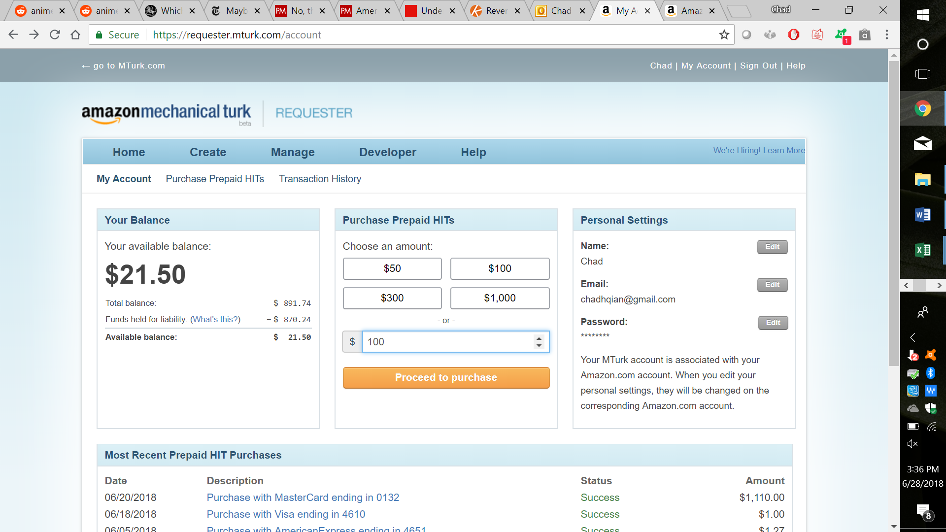

After adding money to your account, you will be emailed a receipt; your transaction history is also at the bottom of your “My Account” page.

1. After you have money on your account, you can now create tasks on Mechanical Turk (these are called Human Intelligence Tasks, or “HITs”). To do this, click on “Create,” then click on “New Project.” A list of possible options will be shown on the left. I’ll go through how to create a survey; however, the procedure is similar for other tasks. Click on “Survey,” then click on “Create Project.”

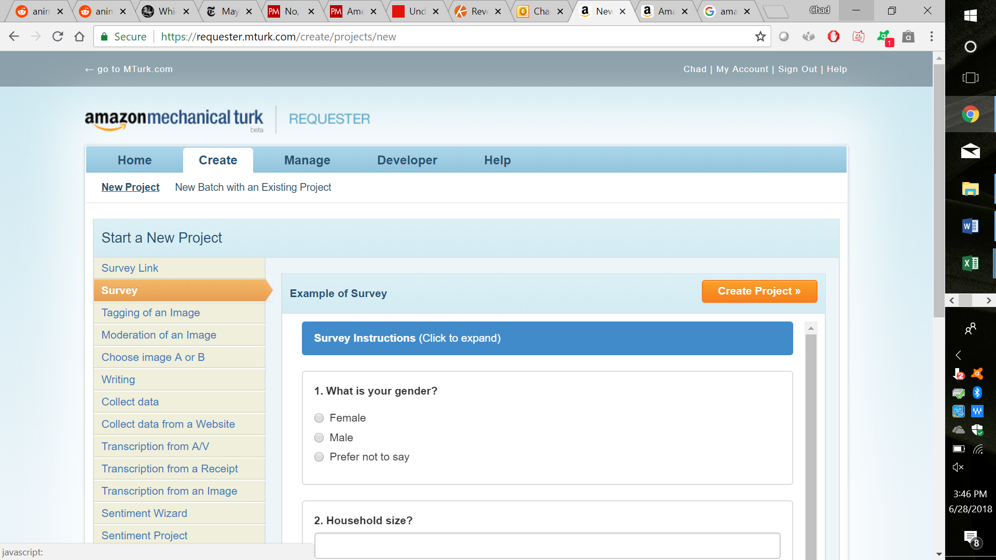

1. The first page you’ll see describes the background information for your survey: its name, how many workers you want, etc. To start off, give your survey a title, description, and keywords. Workers will see these, so make sure they’re relevant and detailed.

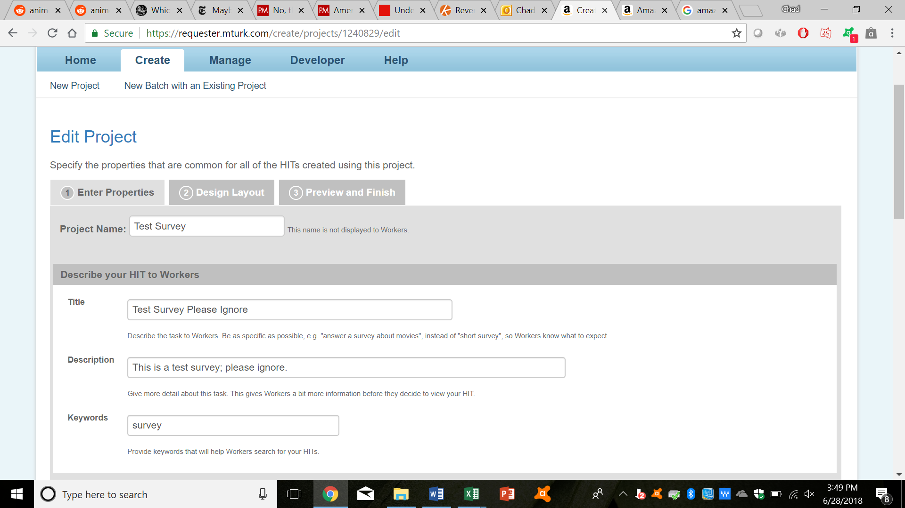

Next, set up payment and worker details. How much do you want to pay workers? How many workers do you want? How much time do you want them to take (be generous here)? When do you want your task to expire? And when do you want to automatically pay workers (this doesn’t matter, if you’re being expedient in manually approving workers)?

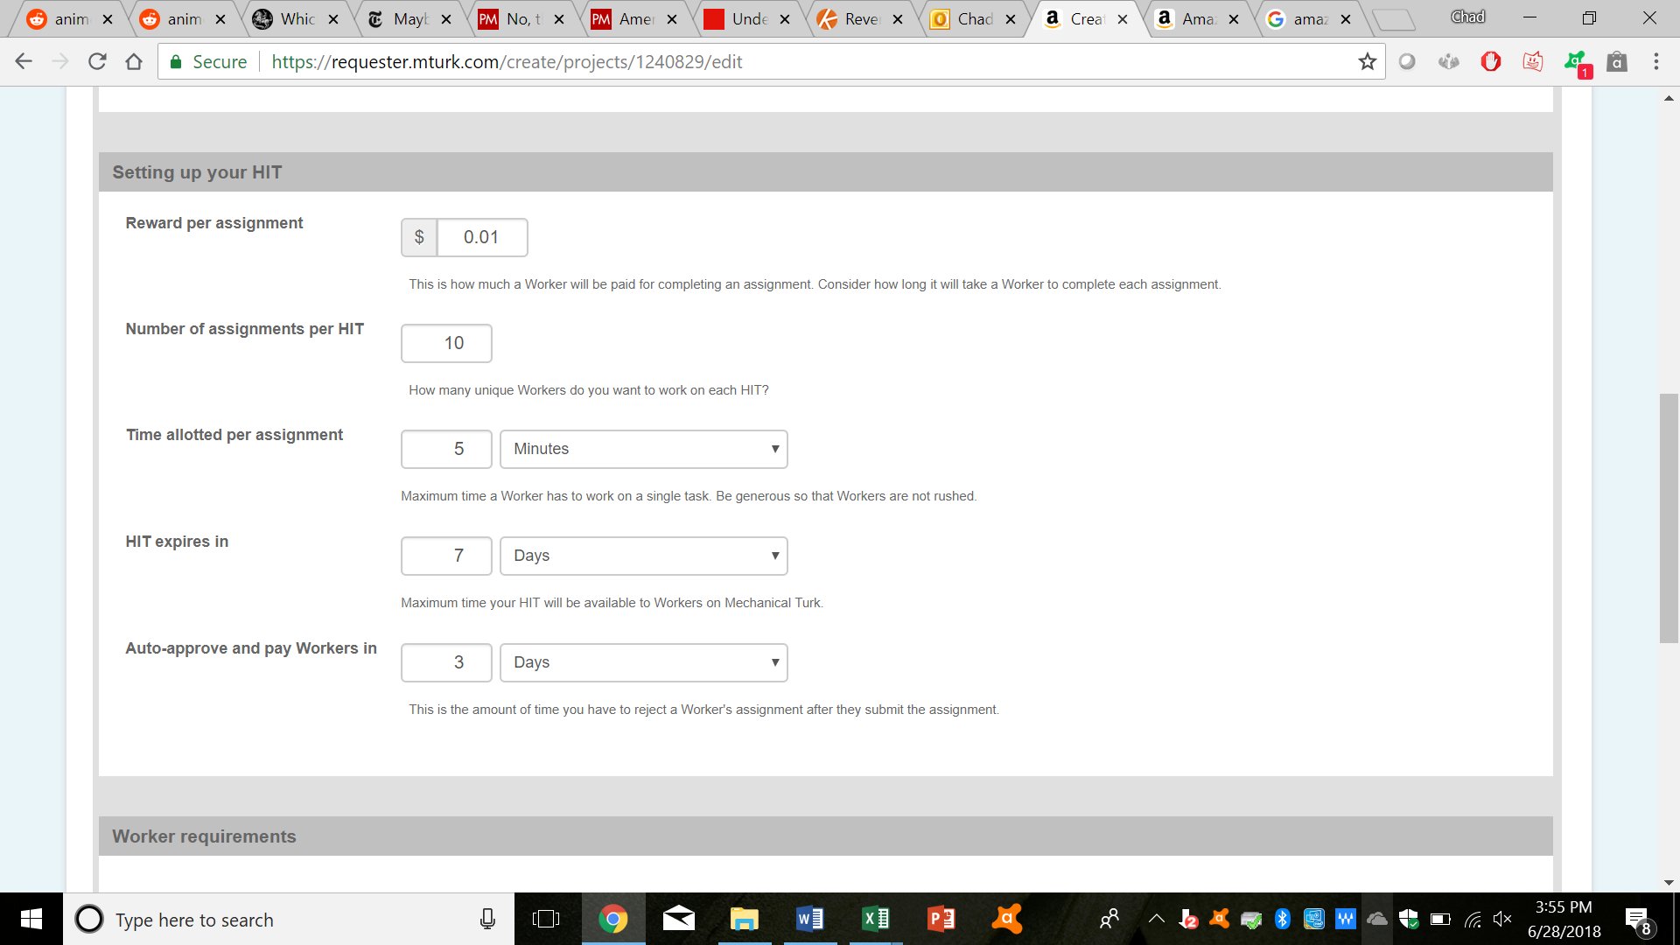

Finally, set up any worker requirements you want. System qualifications and user-defined qualifications (I’ll discuss these later) are free, while premium qualifications are not. If you want your survey to be open to everyone, don’t do anything here.

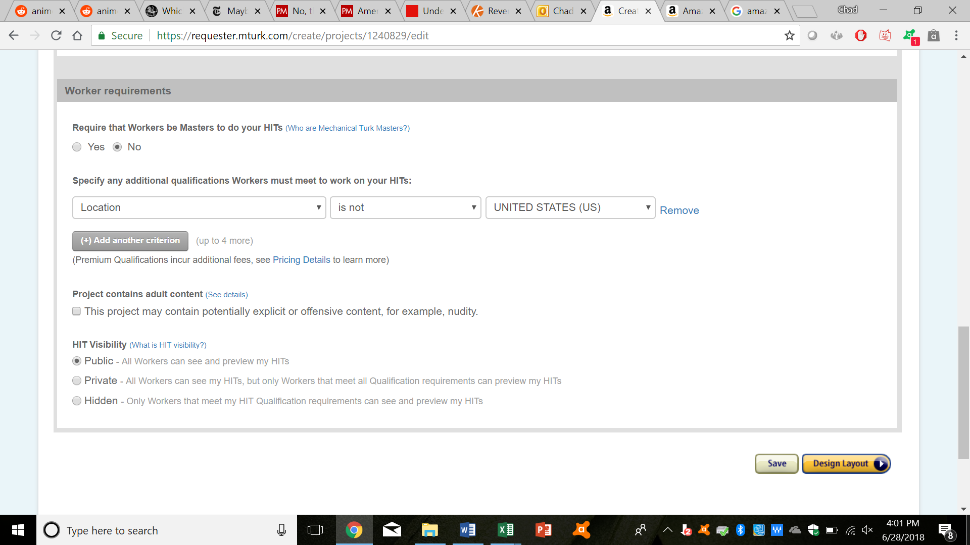

Once you’re satisfied with everything, click on “Design Layout”

1. The next page you’ll see is the actual survey. You’ll need to know basic HTML to put this together; however, the example survey provided likely gives you enough examples of HTML. Click on “Source,” to set up the HTML code behind your survey.

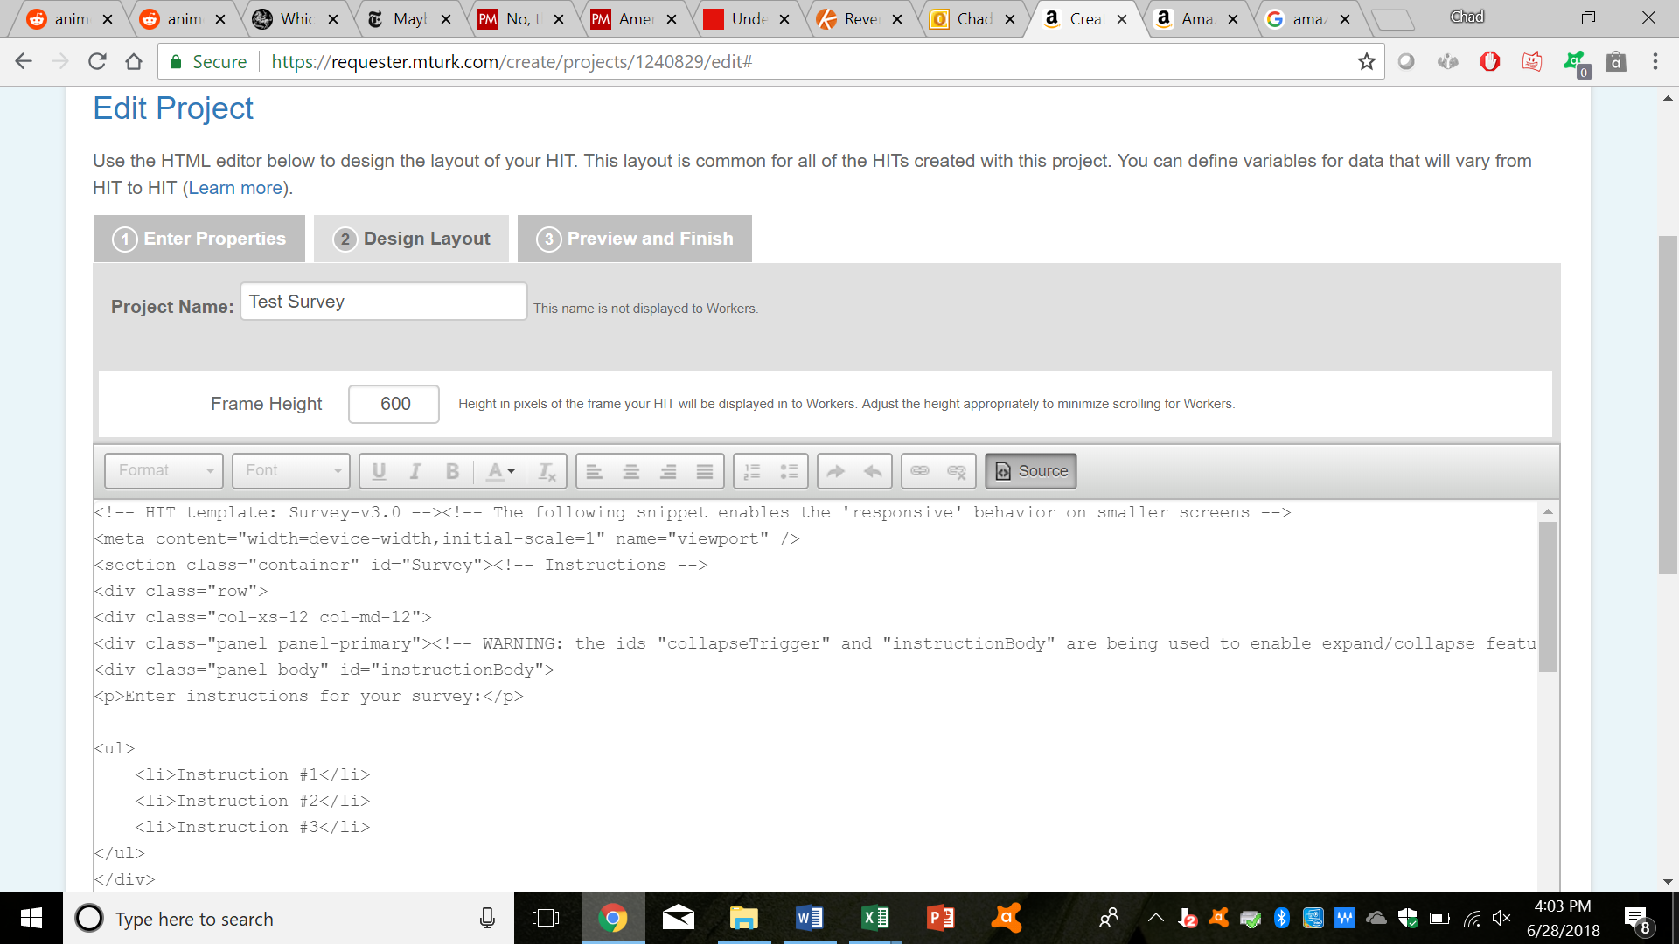

For the most part, you should only have to deal with the code behind “<!-- Survey Layout -->” and “<!-- End Survey Layout -->.” While coding, you can always click on “Source” again, to see how your survey is looking. Once you’re satisfied, click on “Preview.”

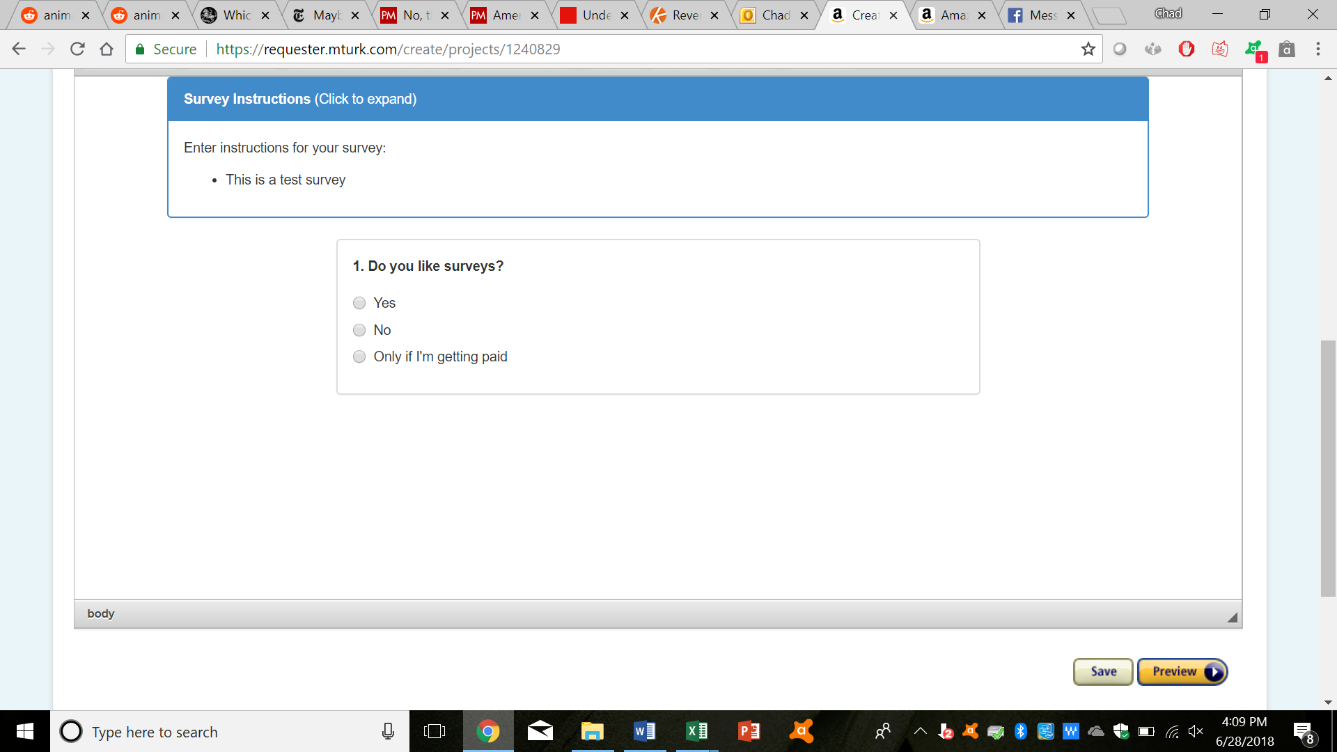

1. You can review your survey one last time. If you’re satisfied, click on “Finish.”

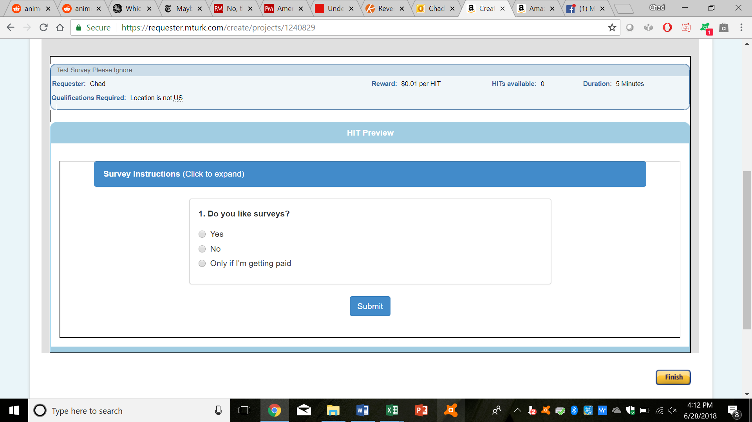

1. You will then be taken to a page containing all of your batches/projects. Click on “Publish Batch” for the desired project.

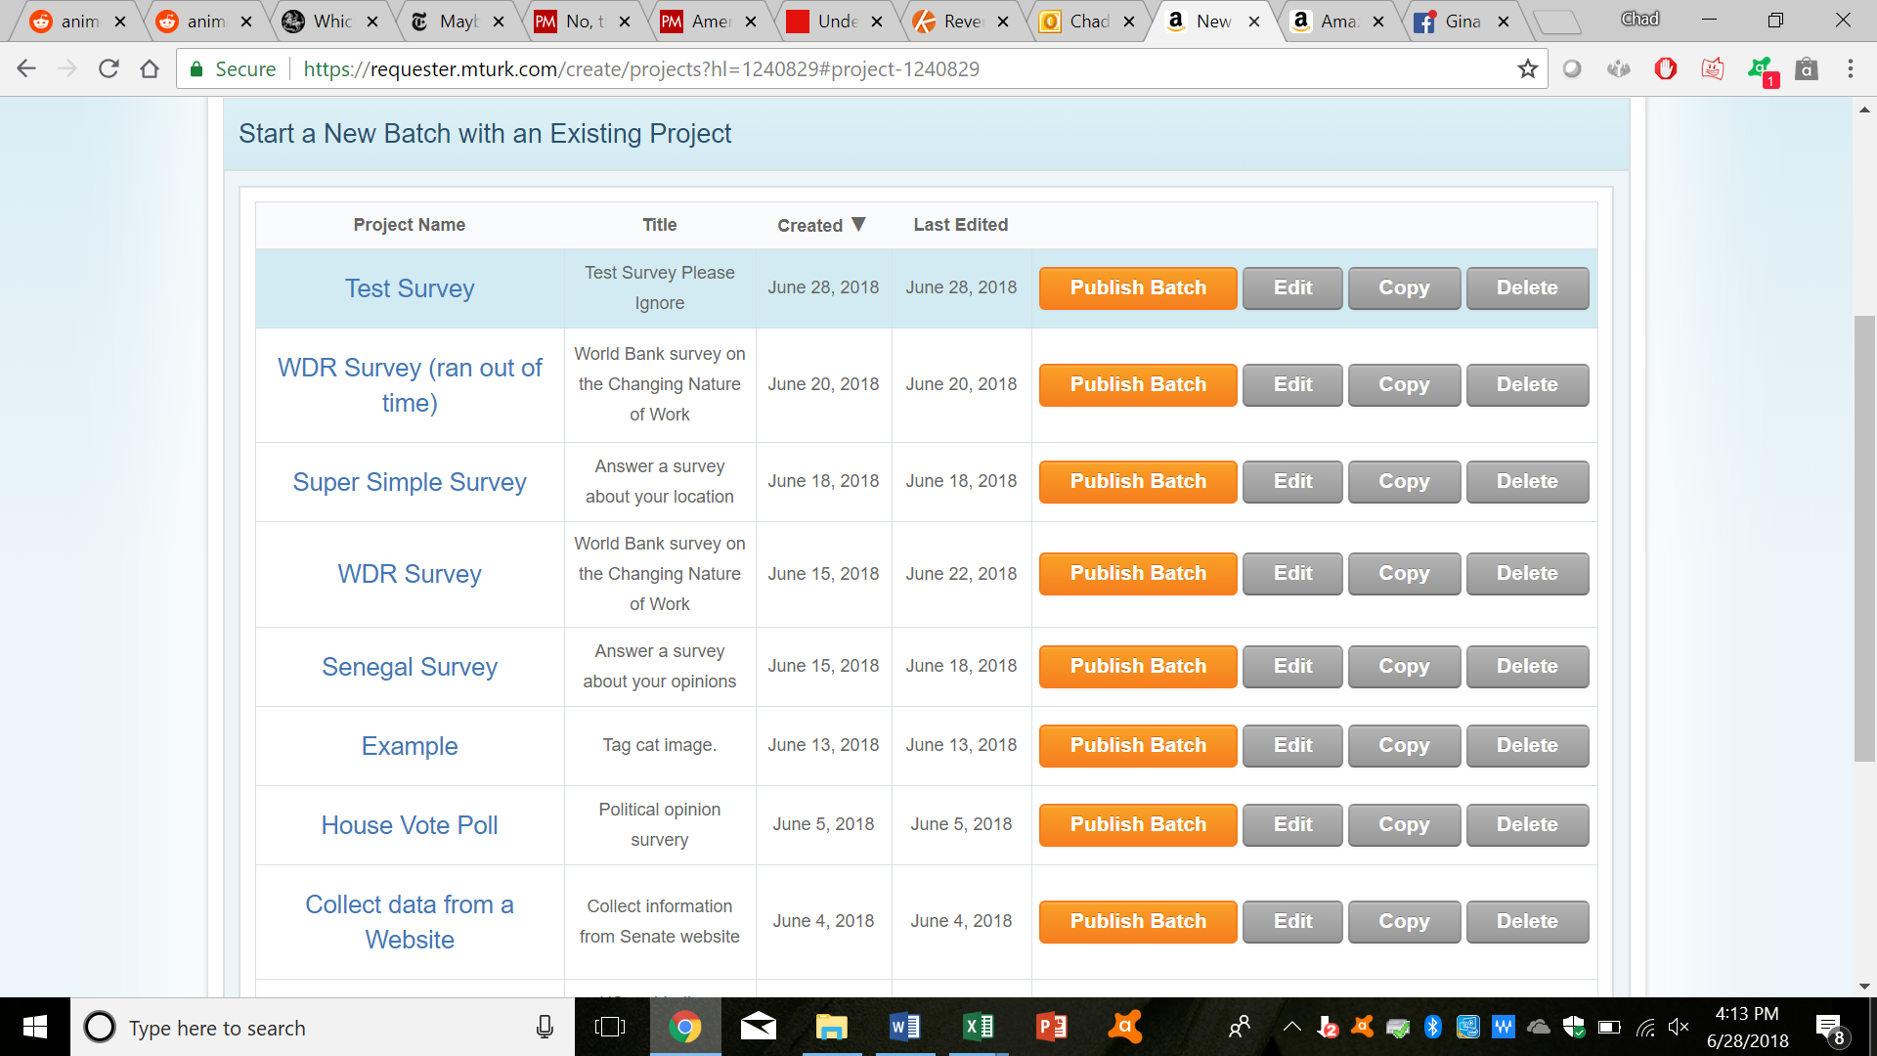

You can review your survey one last time. If you’re satisfied, click on “Next.”

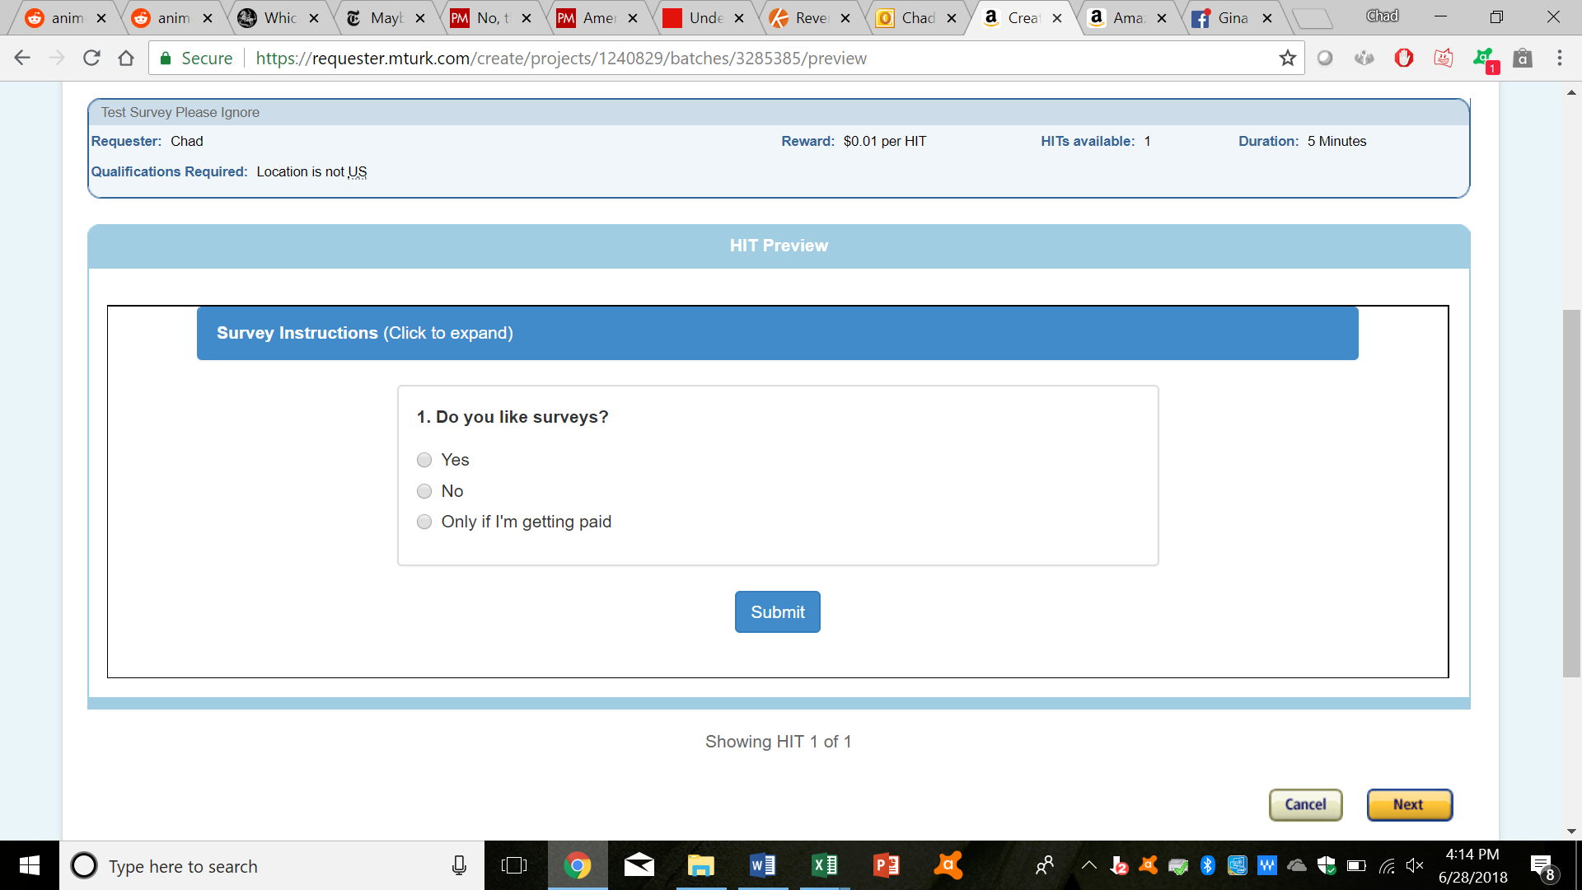

You have one last opportunity to preview your survey. Once you’re satisfied, click on “Publish.”

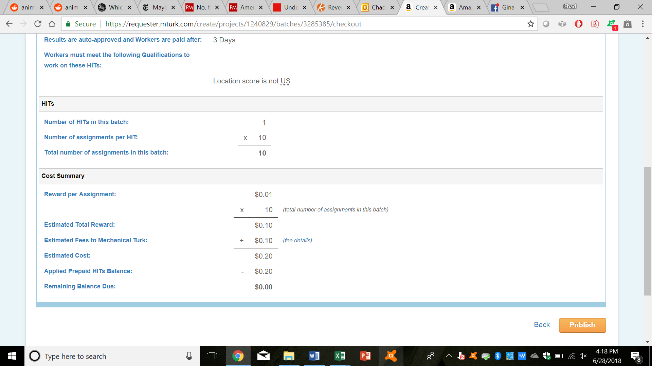

1. You can now monitor progress for your survey on the current page.

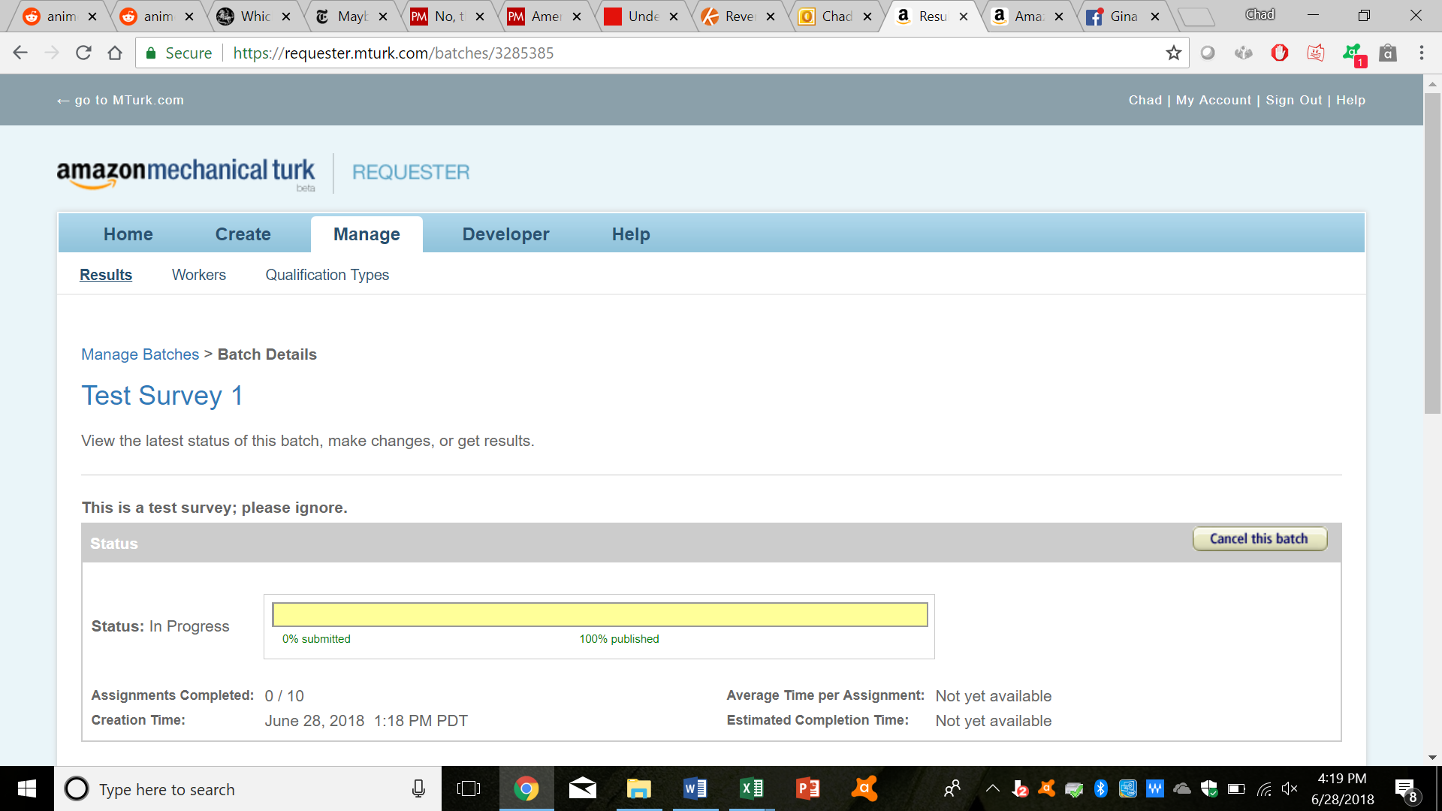

To see all of your ongoing HITs, click on “Manage” at the top.

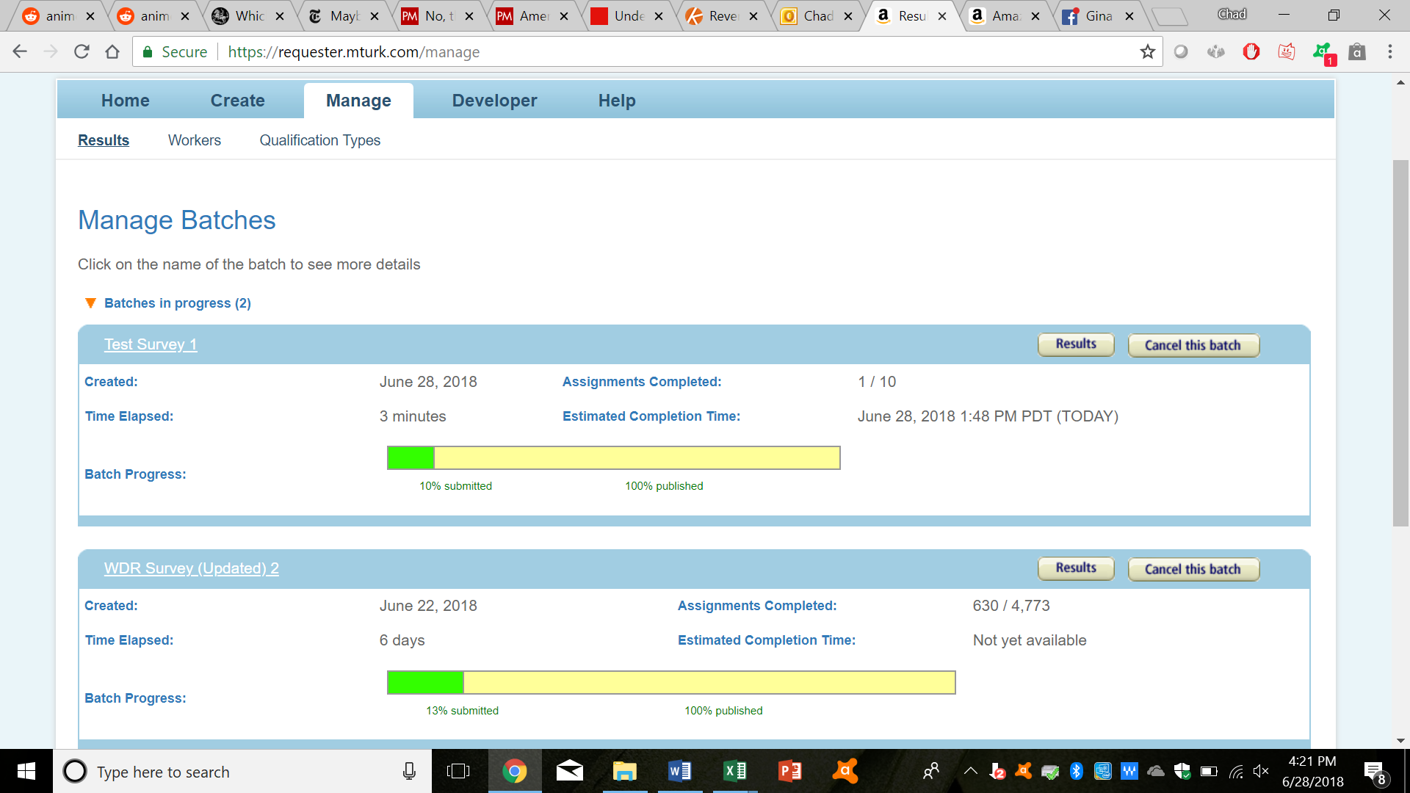

And for more detailed results, click on “Results.”

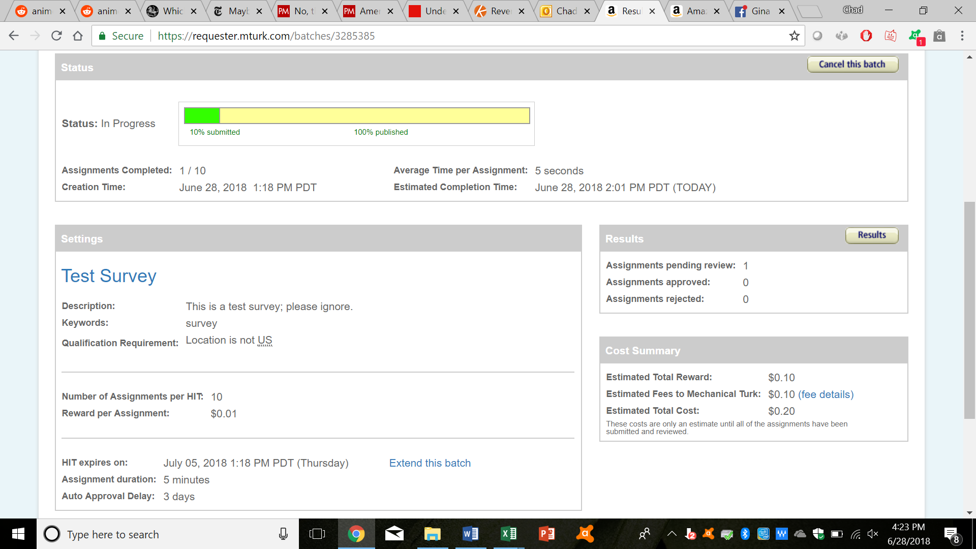

1. From the results page, you can see all of the responses that have been submitted. You can also approve or reject these responses here, by clicking the checkbox next to those responses and click on “Approve” or “Reject,” respectively.

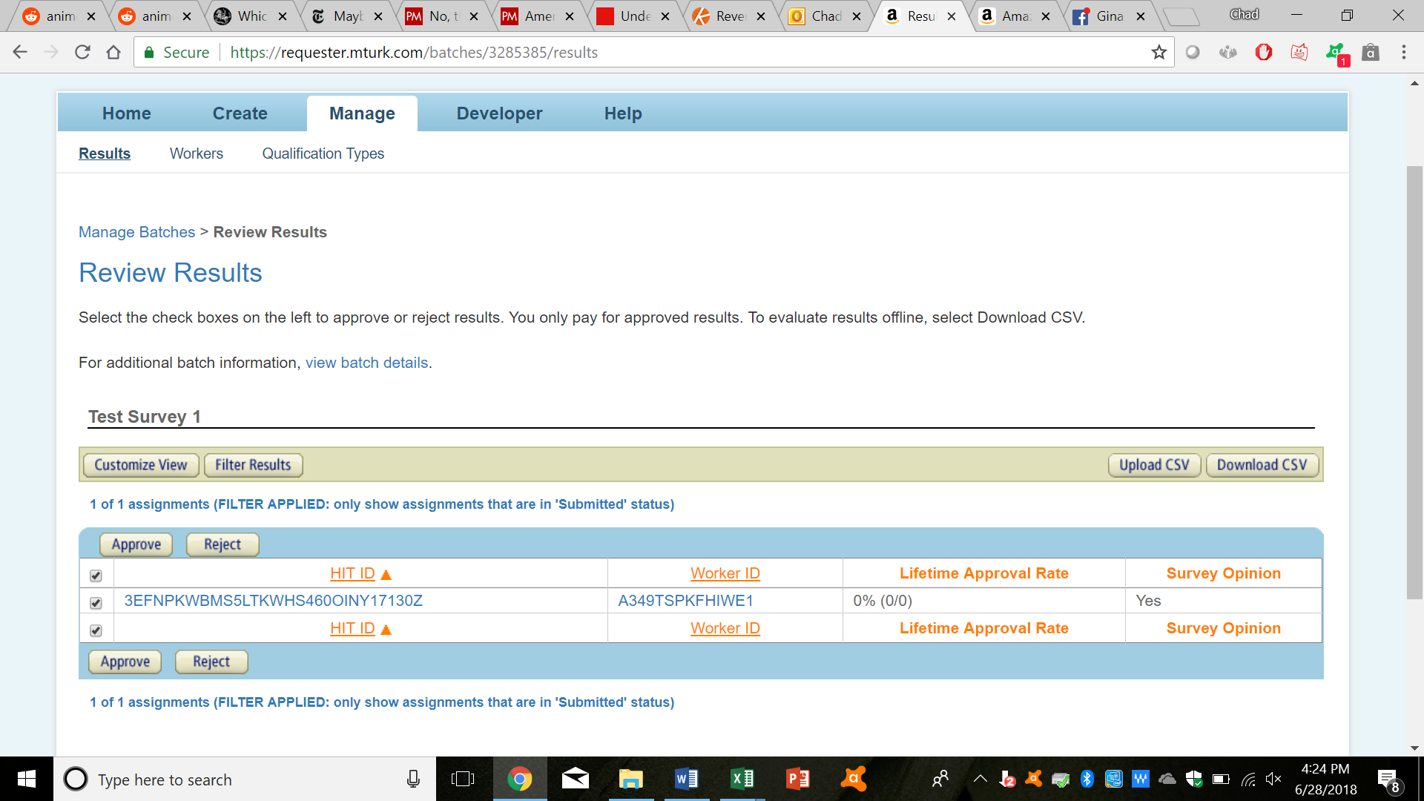

You can customize what you see, by clicking on “Customize View.” You can also see all results by clicking on “Filter Results,” and then unchecking the box next to “Status Filter.”

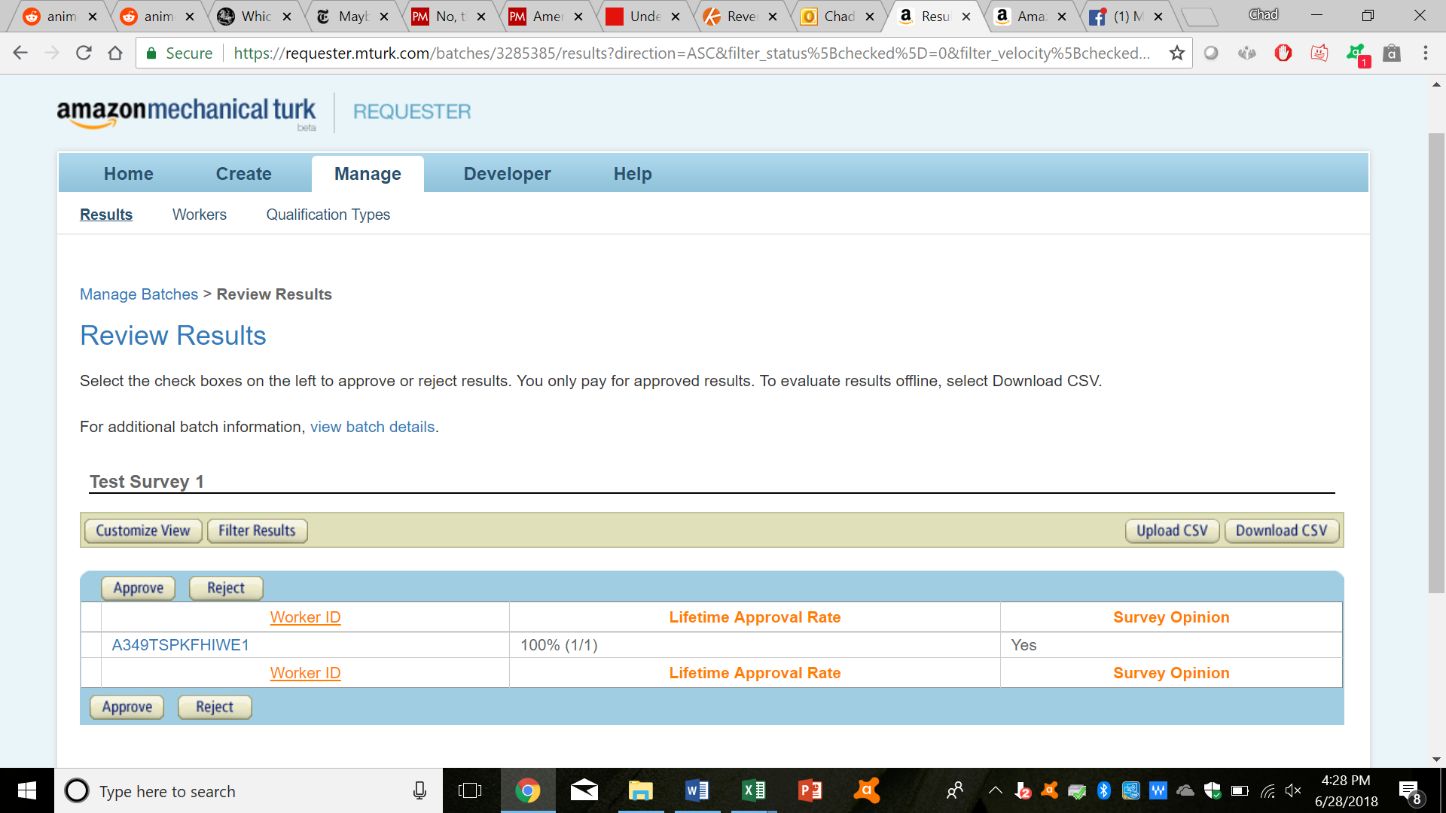

1. And that’s basically it, for the basics!
2. **More Aspects:**
3. Downloading CSV files:

* You can download a CSV file, containing all the responses, by clicking on the “Download CSV” button.



You can also approve or reject workers, by either placing a “x” under the “Approve” column or providing a reason for rejection under the “Reject” column, and then uploading the new file by clicking on the “Upload CSV” button.

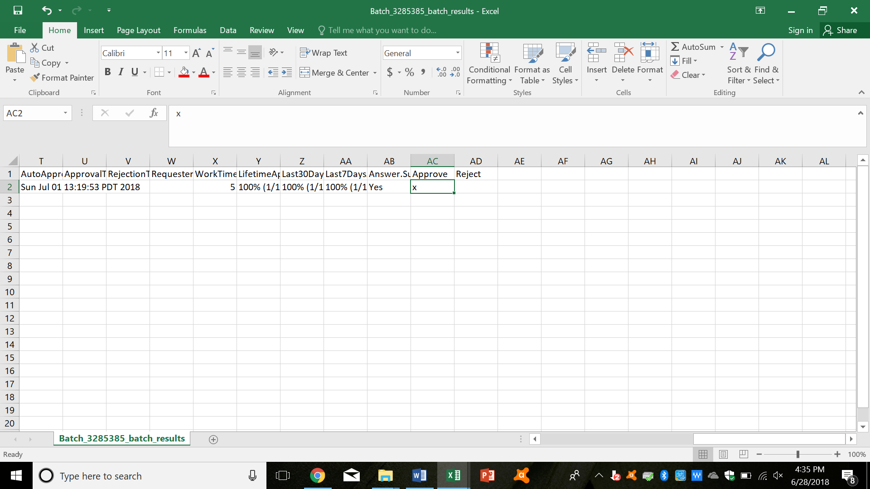

You can approve and reject people in the CSV file manually, or you can use a program to do it (I will talk about this later).

1. Awarding Bonuses:

* You can award bonuses to workers; you can use these to motivate workers to work extra hard or be more creative. To do this, first find the worker. You can do this on the results page for your task:



Or you can do this on the overall workers’ page, which you can get to by clicking on “Workers.”

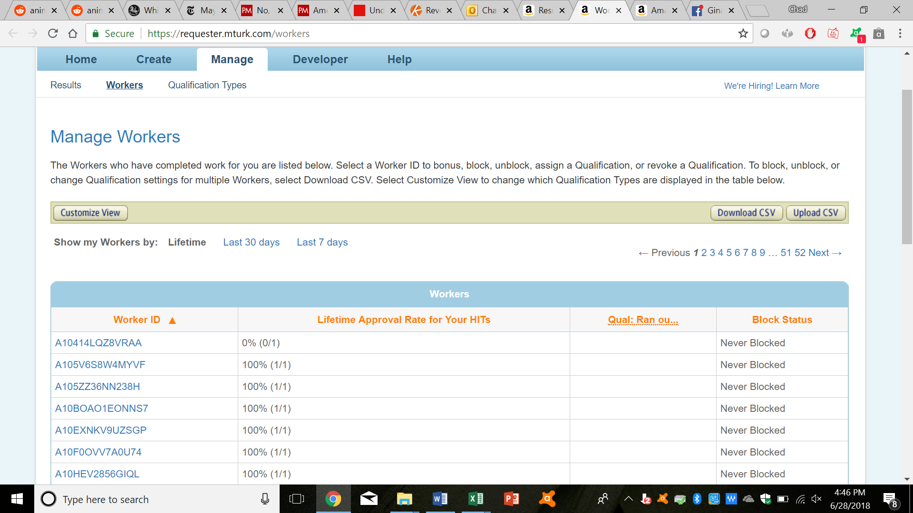

Then, after finding and clicking on your worker’s “Worker ID,” click on “Bonus.”

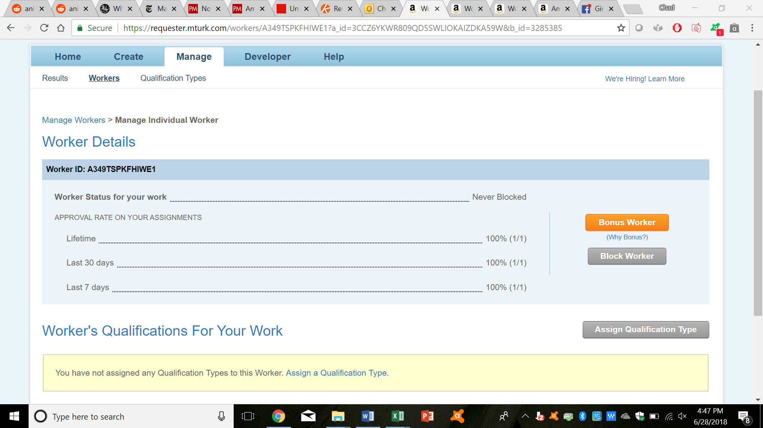

Then put in the bonus amount and your reason for awarding a bonus, and click on “Pay Bonus Now.”

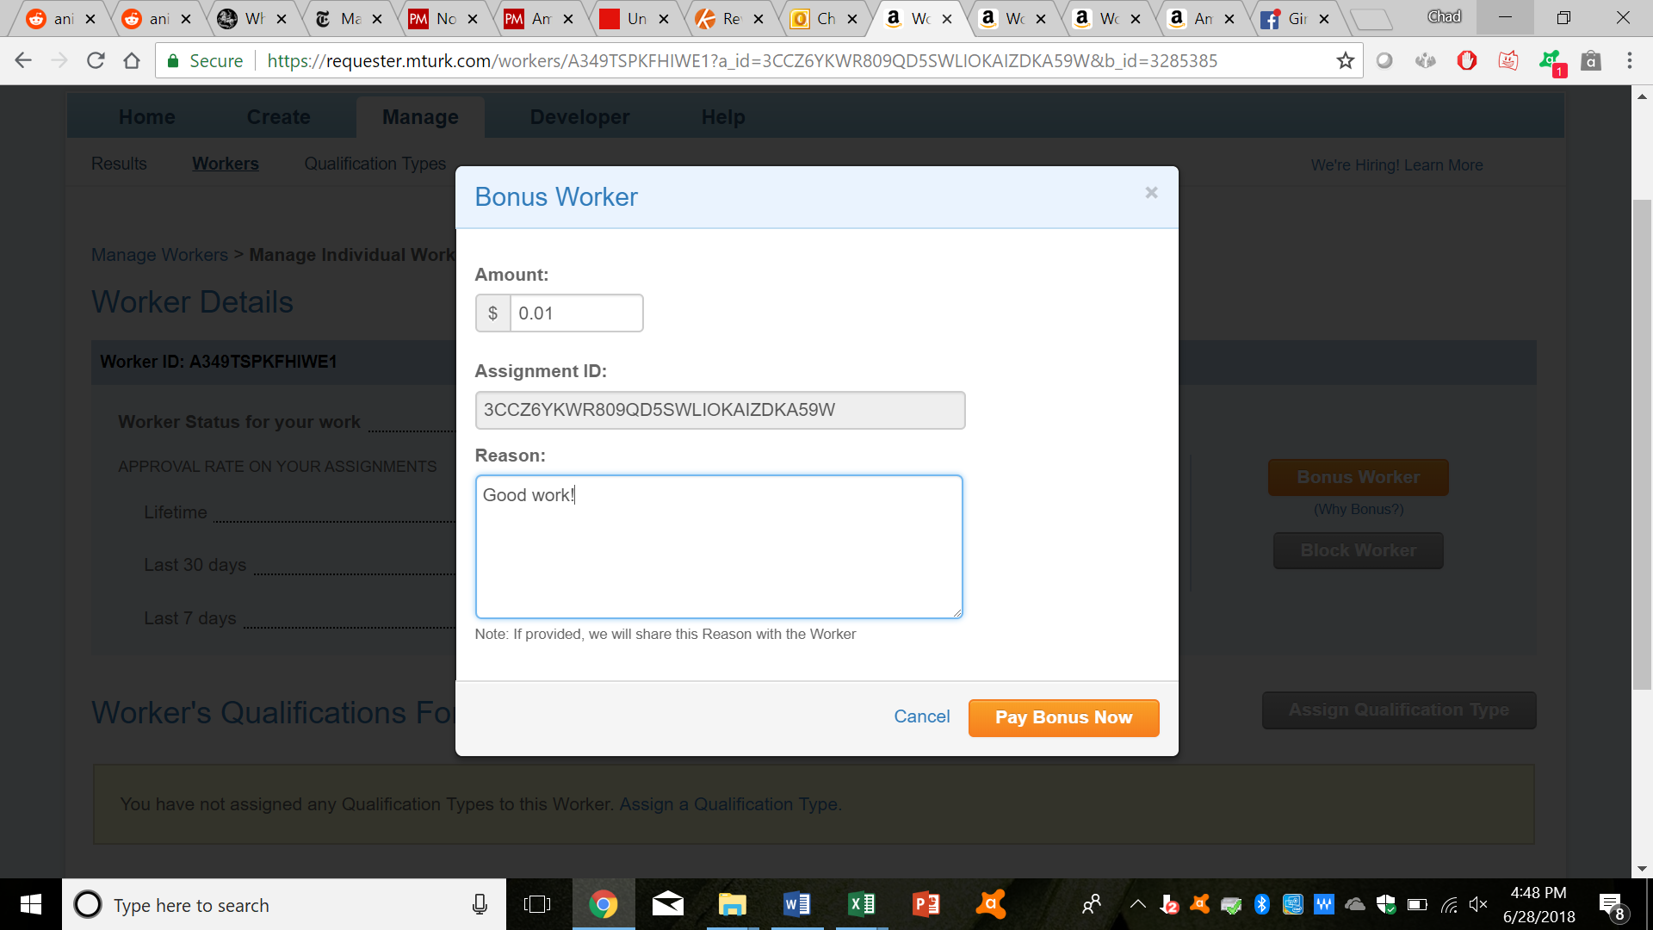

1. User-defined Qualifications:

* First, to create a new qualification, click on “Manage,” and then on “Qualification Types.”

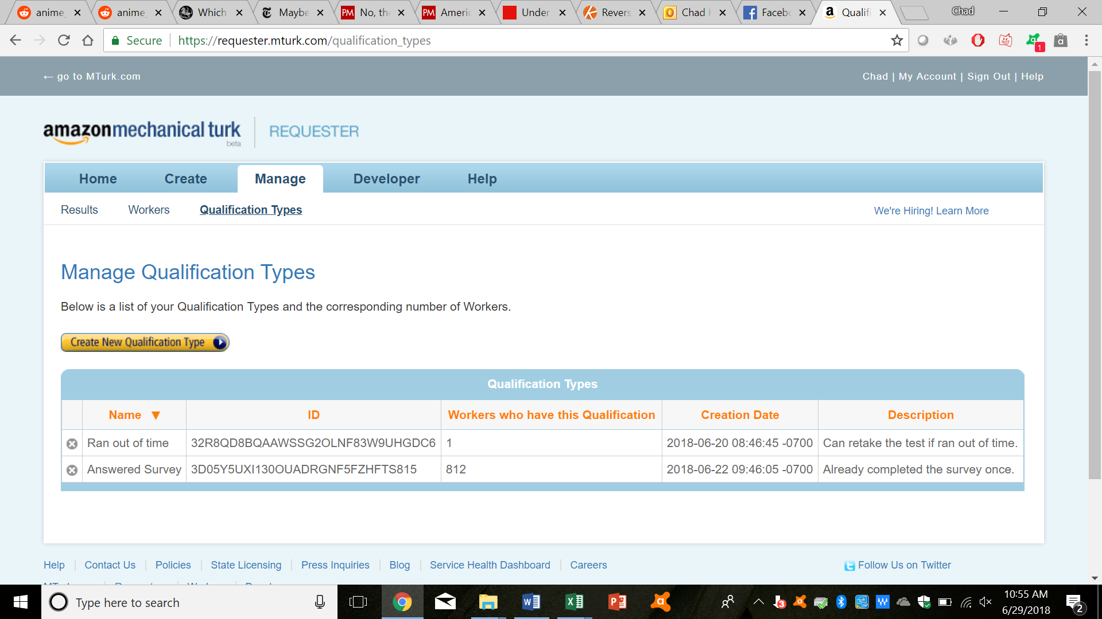

* Next, click on “Create New Qualification Type.”
* Enter in your desired title and description. When satisfied, click on “Create.”

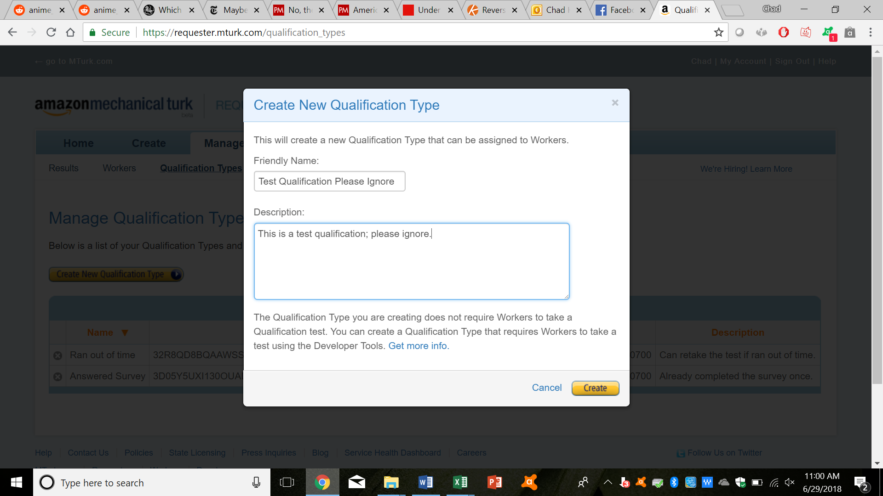

* And now you have a new qualification type!

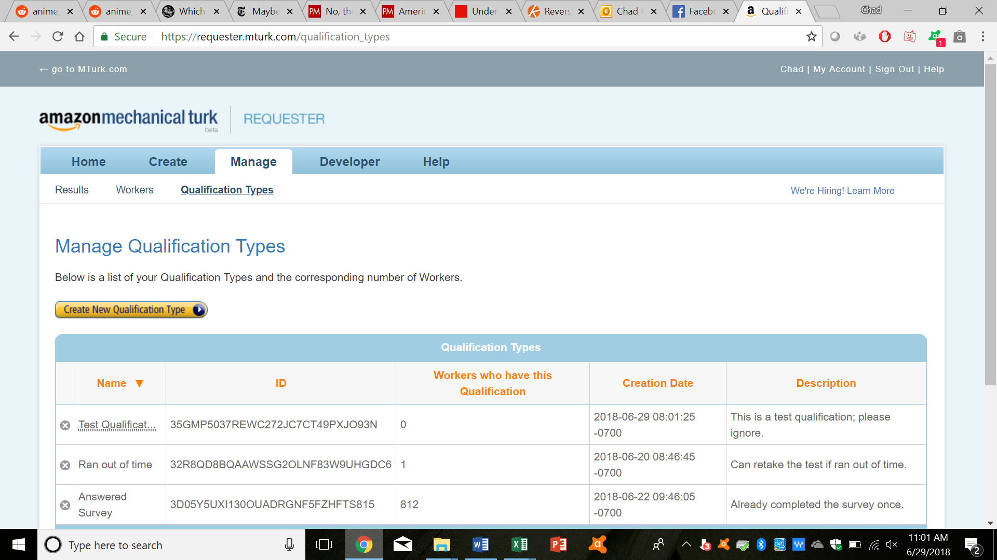

* Now, like bonuses, you can assign these qualifications to certain workers. To do this, find the worker first, as above. Then, after clicking on their “Worker ID,” click on “Assign Qualification Type.”

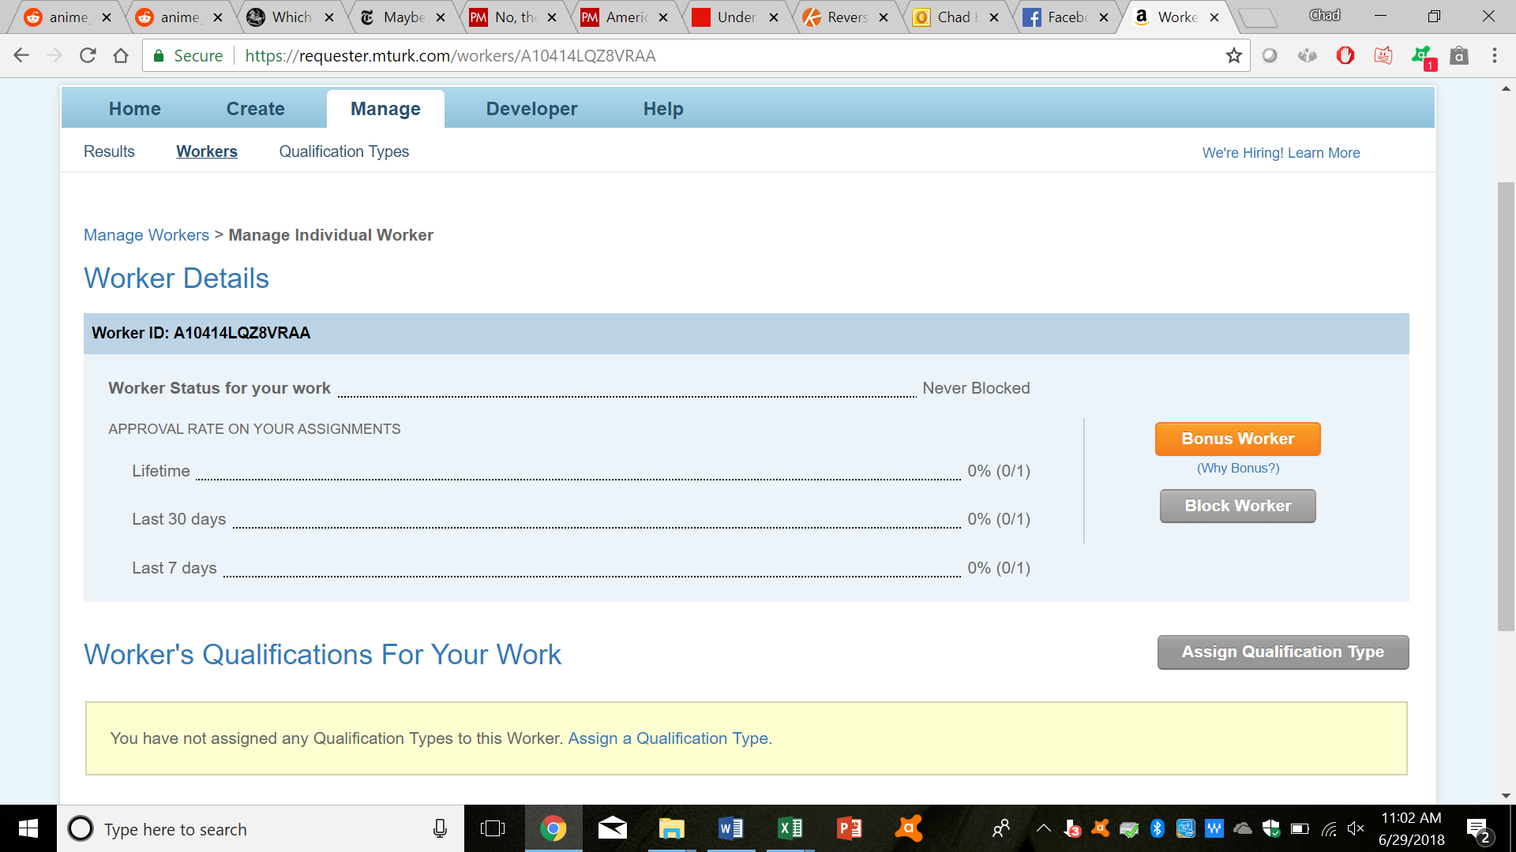

* You can also assign a corresponding “score” to workers; this might be useful for certain tasks, although I haven’t really used it. If you don’t need it, you can just enter in “100.” Either way, once you’re satisfied, click on “Assign.”

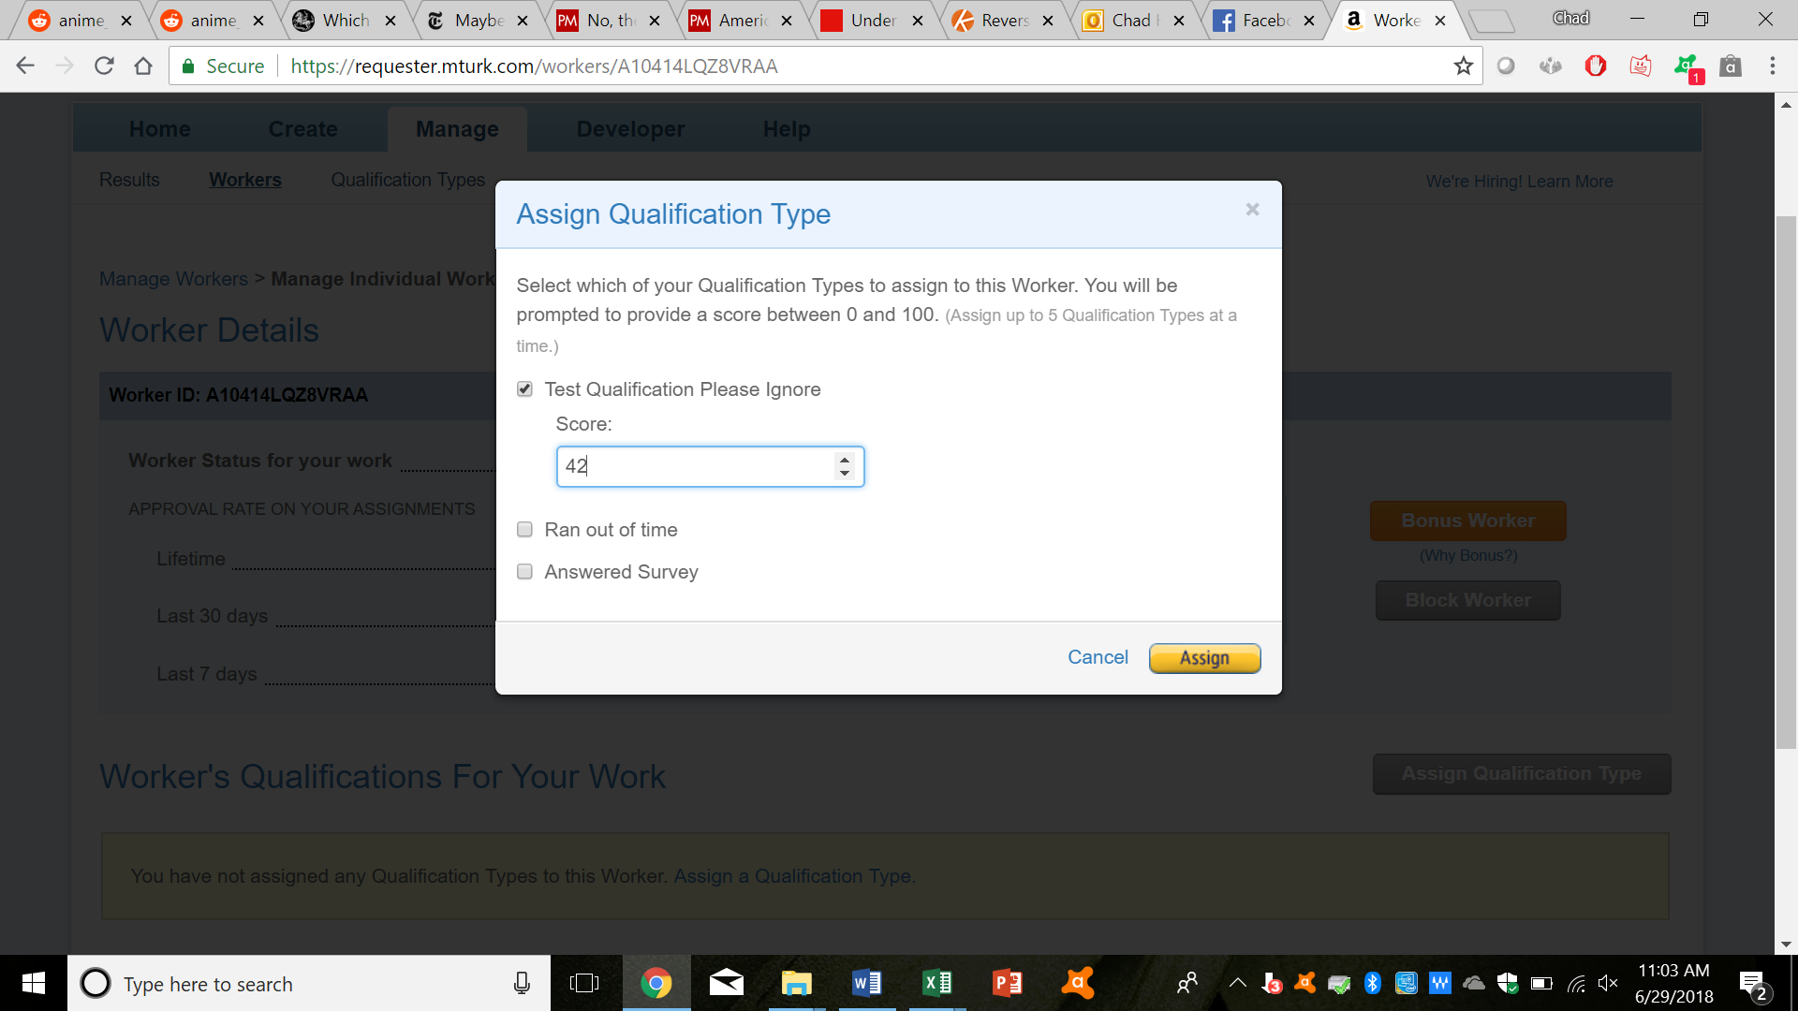

* You can also assign qualifications to workers by downloading the worker CSV file, and marking on there. To do this, first navigate back to the page containing all workers, and then click on “Download CSV.”

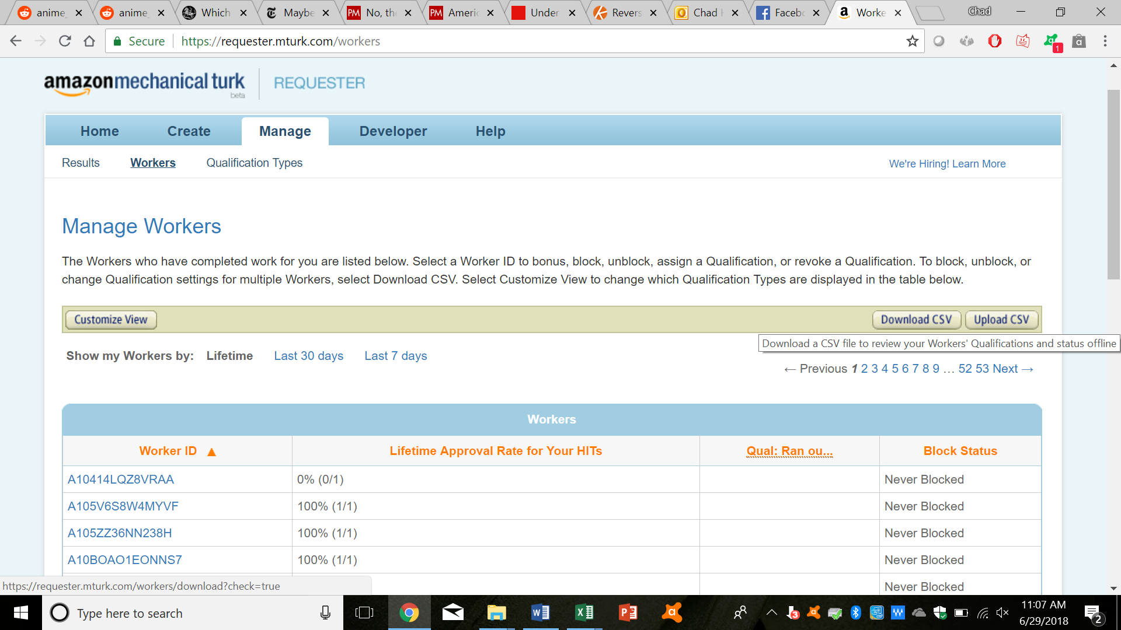

* Now, you can enter in your desired “score” for your desired worker in the column for your desired qualification (the column name would be “UPDATE-Test Qualification Please Ignore” in this case.)

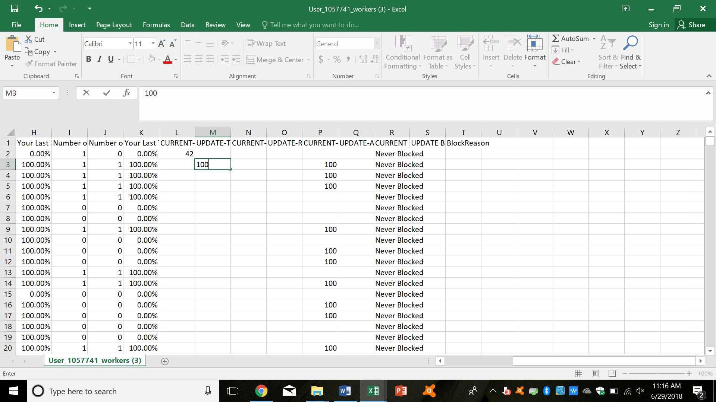

* After doing this, save your CSV file, and upload it back onto Amazon Mechanical Turk, by clicking on the “Upload CSV” file.
* You can use qualifications when you’re setting up tasks. For example, say you’re publishing a survey, and want to limit it to people who have been assigned a certain qualification. To do this, on the first page of task setup, first click on “Add another criterion.”

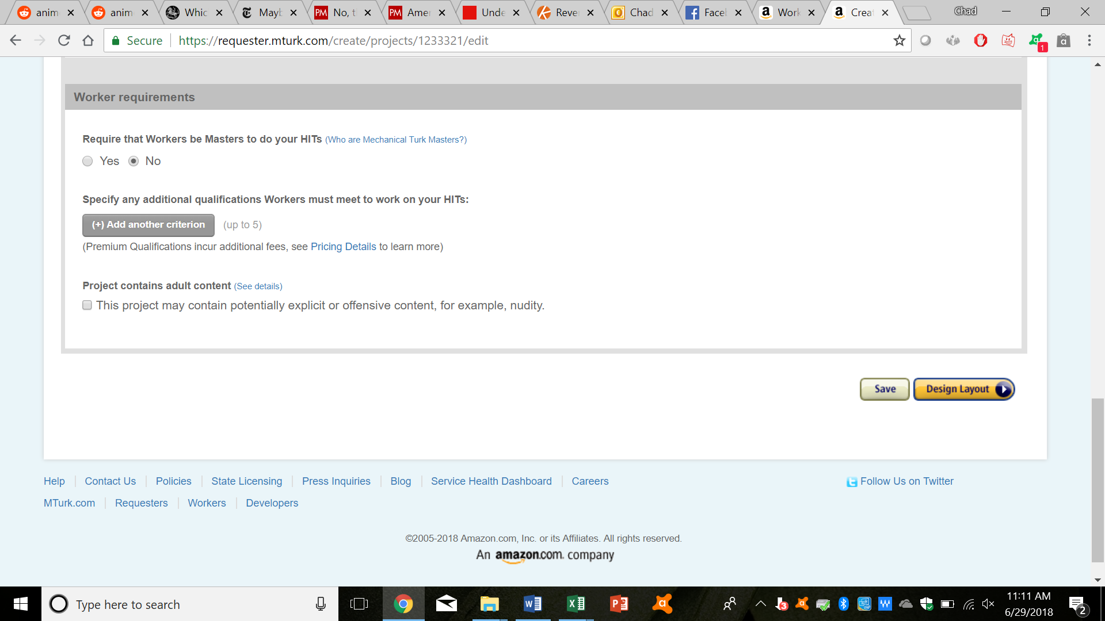

* Scroll down and click on your desired qualification type

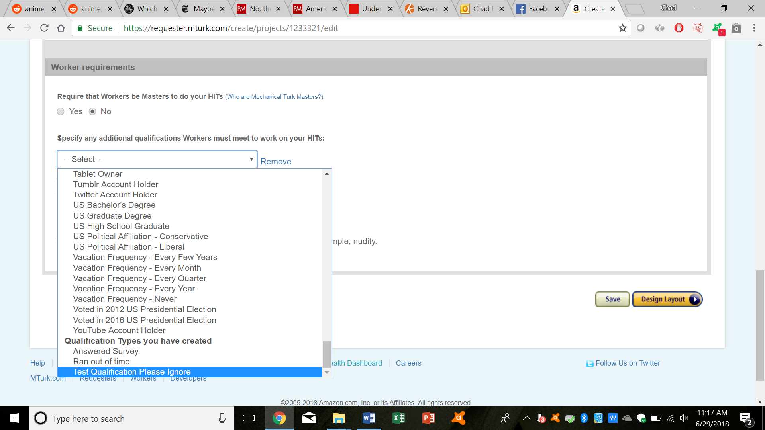

* Then you can play around with the other choices; for this example, since we want to limit this task to people who have this qualification, we simply choose and click on “has been granted.”

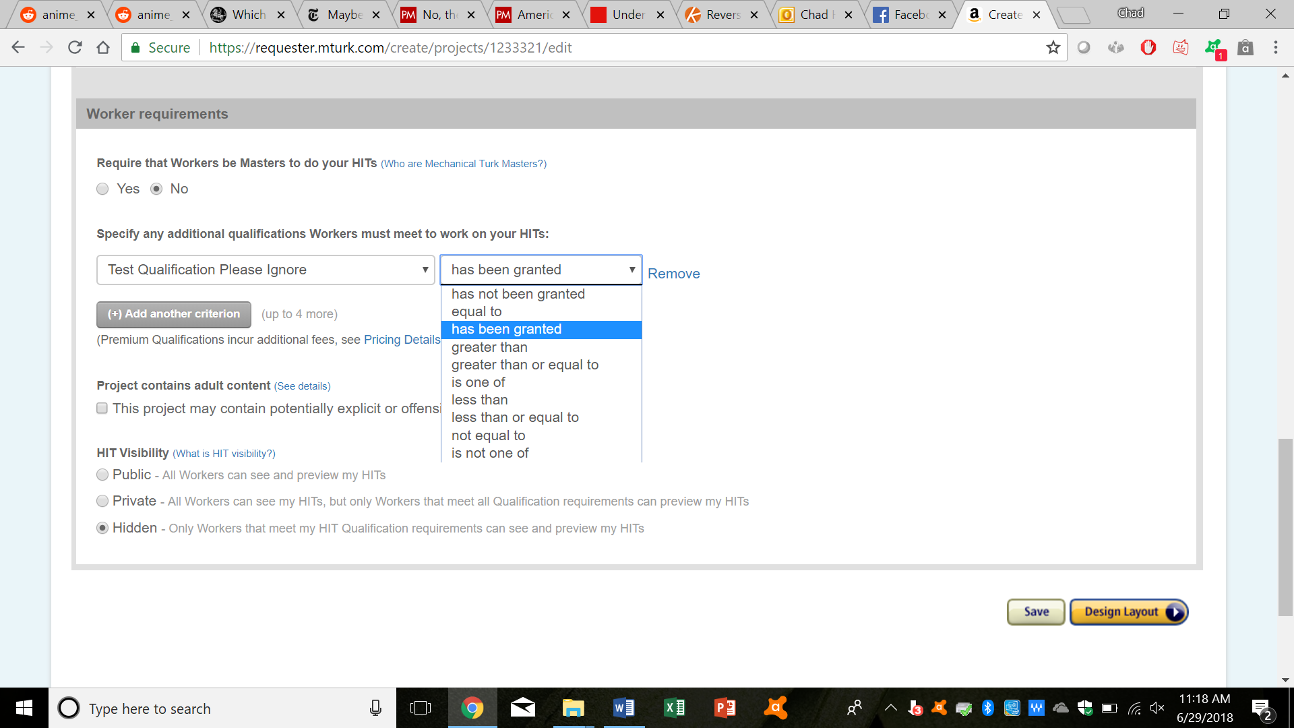

* You can then proceed with creating the task, as normal.

1. Batches:

* This aspect is useful if you have a huge chunk of data that you want to be processed, each in a discrete HIT. So, for example, say you want to tag images of cats. First, start to create the task, as normal. Then, move on to writing the HTML code for your task. Normally, if you were including a picture, you would write the URL for the picture in the HTML code. Instead, just write “${image_url}” as shown below.

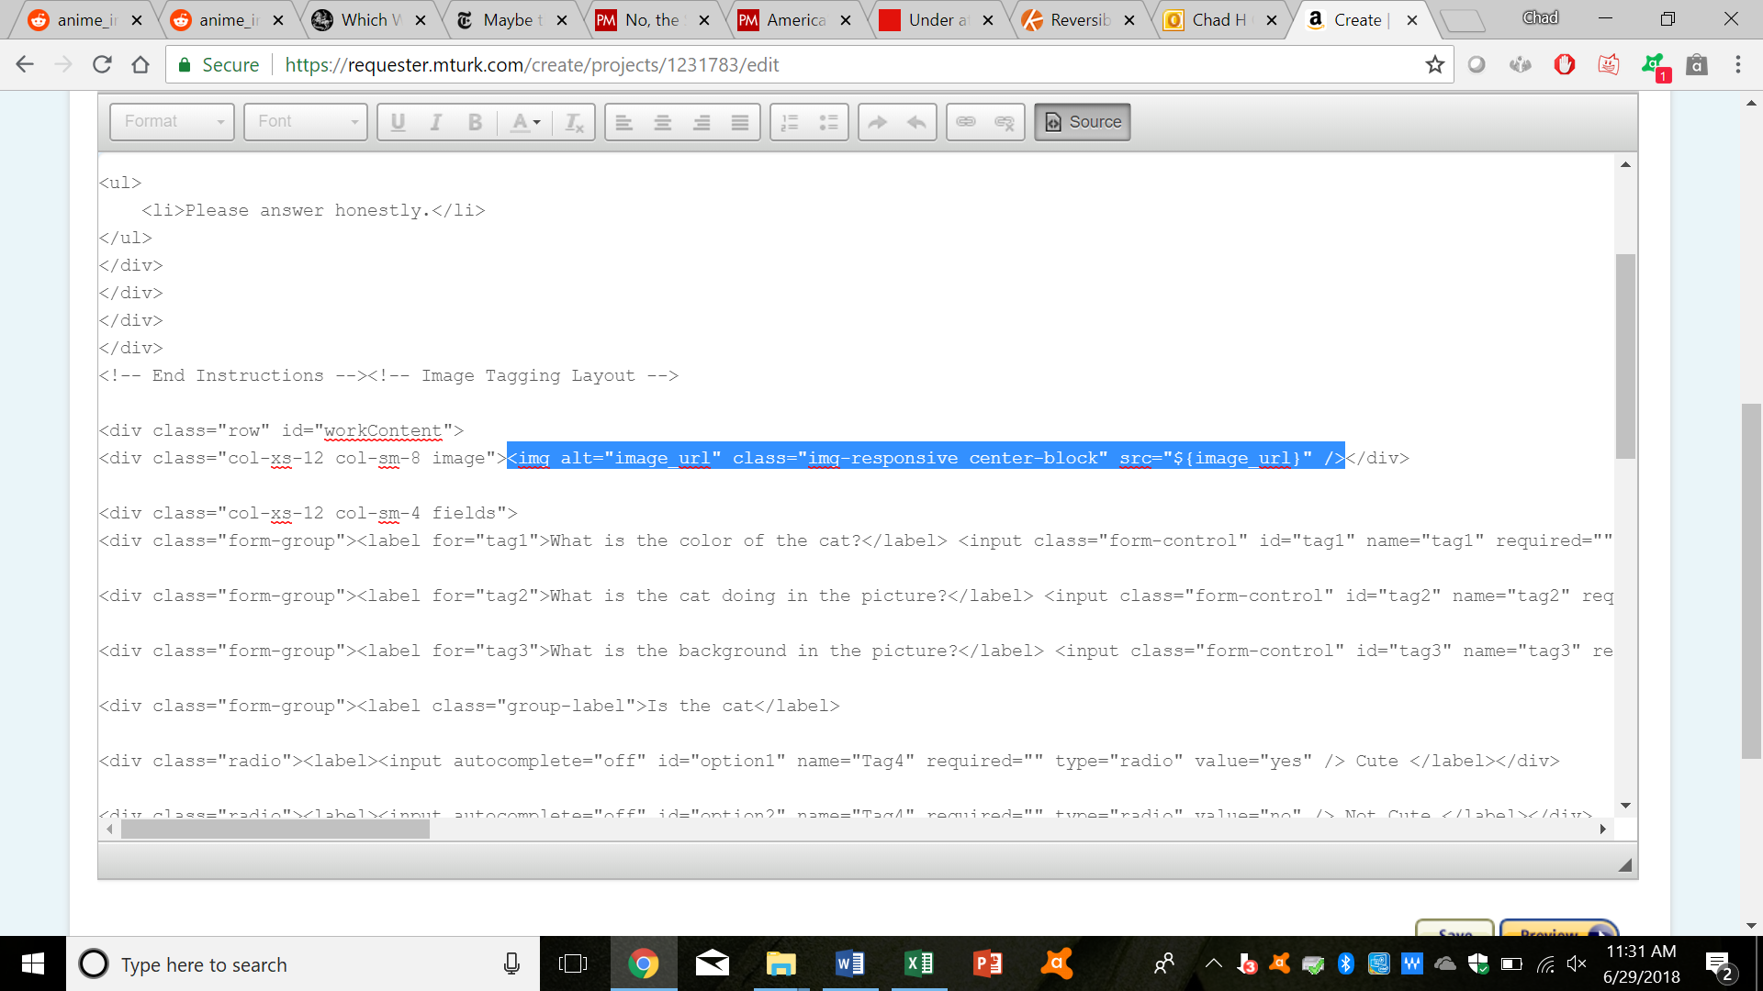

* Continue creating the task, as normal. After you’re done, go the page containing all your projects, find your current one, and click on “Publish Batch” as usual. Now, however, it will ask you to upload a CSV file.

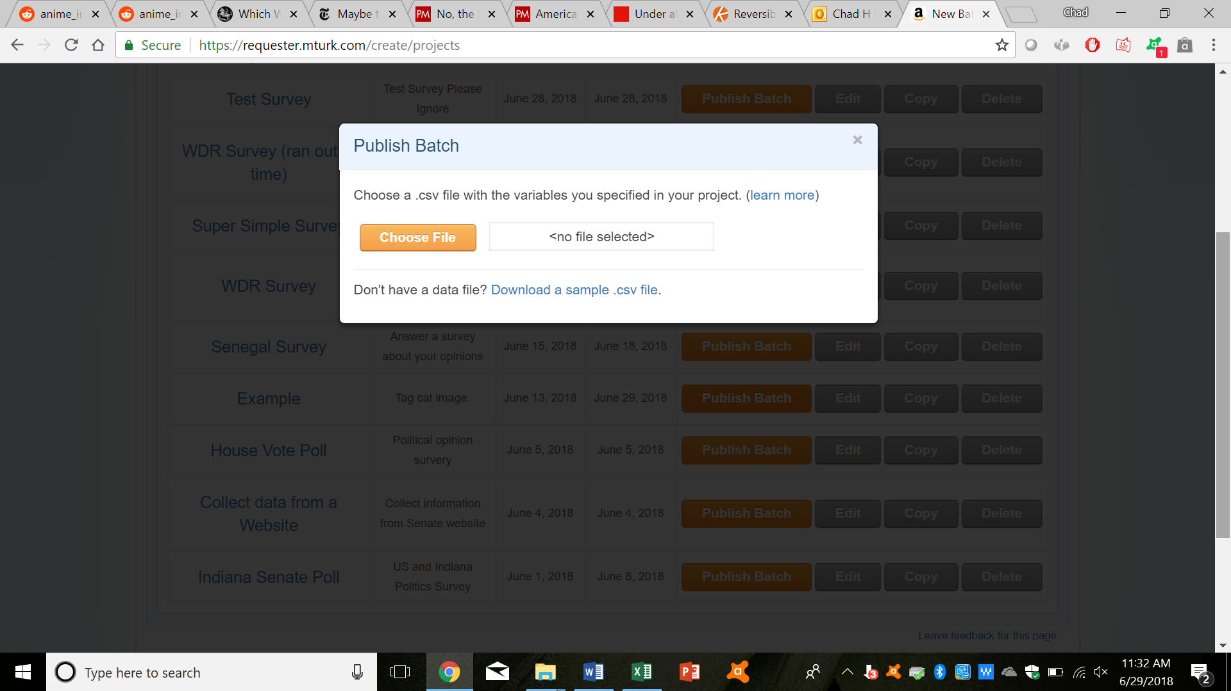

* This CSV file needs to contain instances for the variable “image_url” as shown below

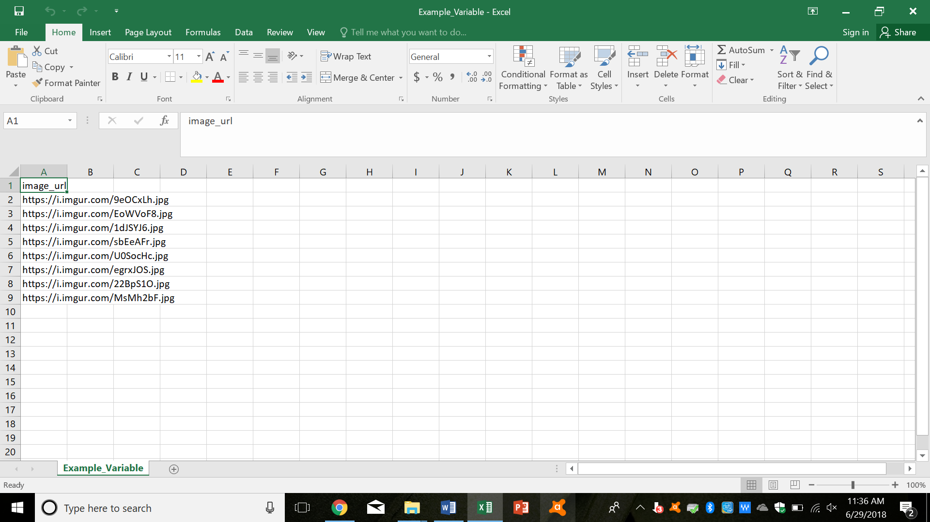

* After uploading your CSV file, you can preview what all of your HITs will look like:

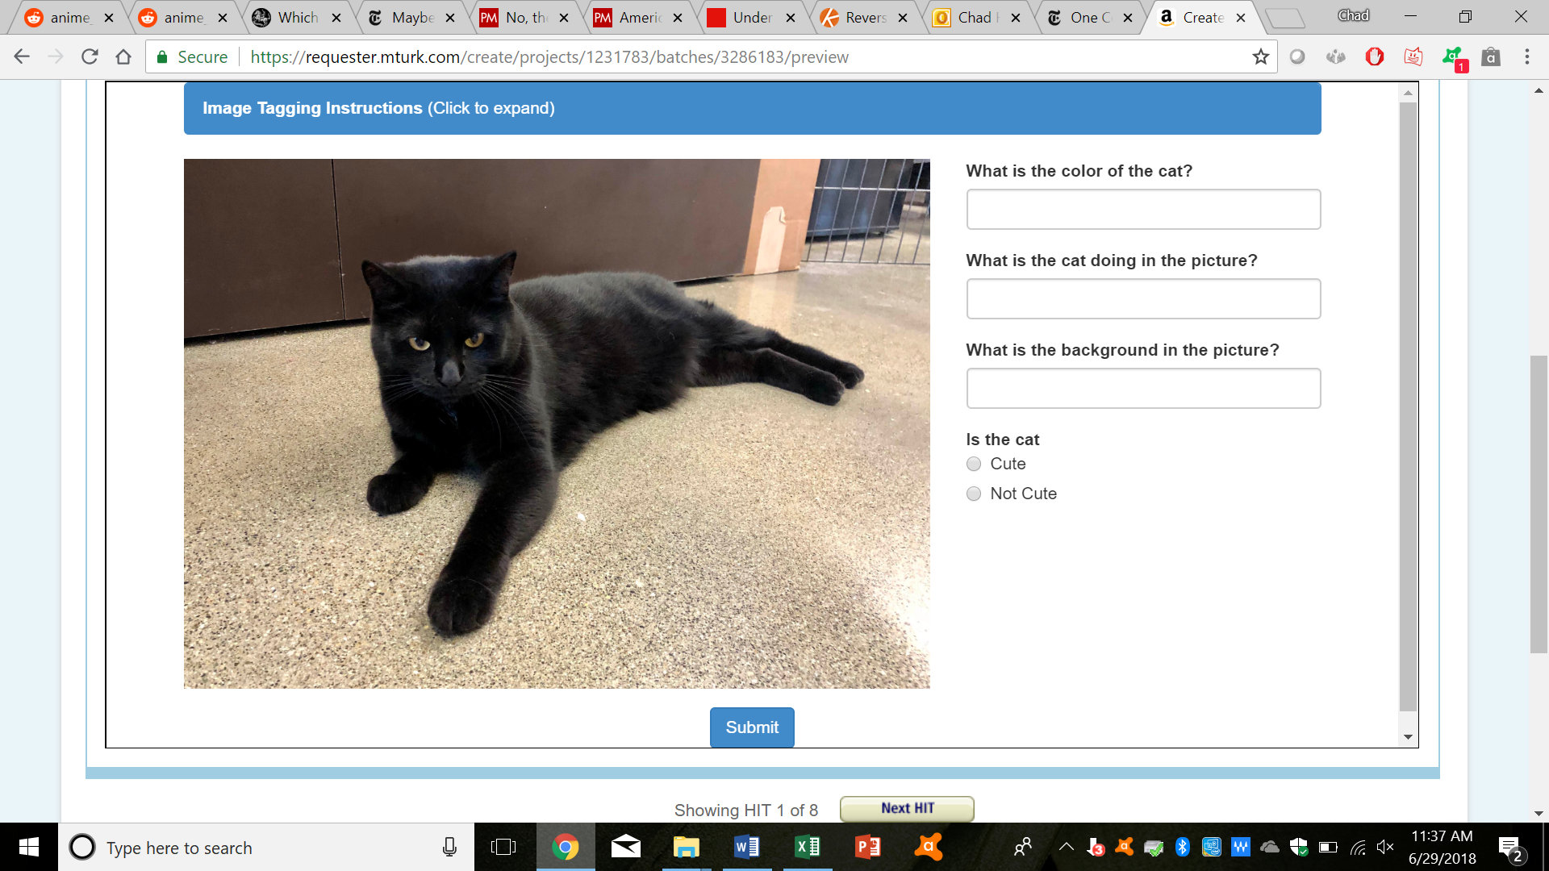

* Once you’re satisfied, you can click on “Next.” This takes you to the final page, where you can review your batch, as normal. Once you’re satisfied, click on “Publish.”

1. **Programming:**
2. Approving or rejecting work:

* You can write a program that approves (or rejects) everyone who passes (or fails) a “reading check” question in the survey successfully. For reference, check file “Hit Approver.py”
* This is useful in just automating the process of approving or rejecting work.
* To start off with, start by downloading the relevant CSV file, as described above.

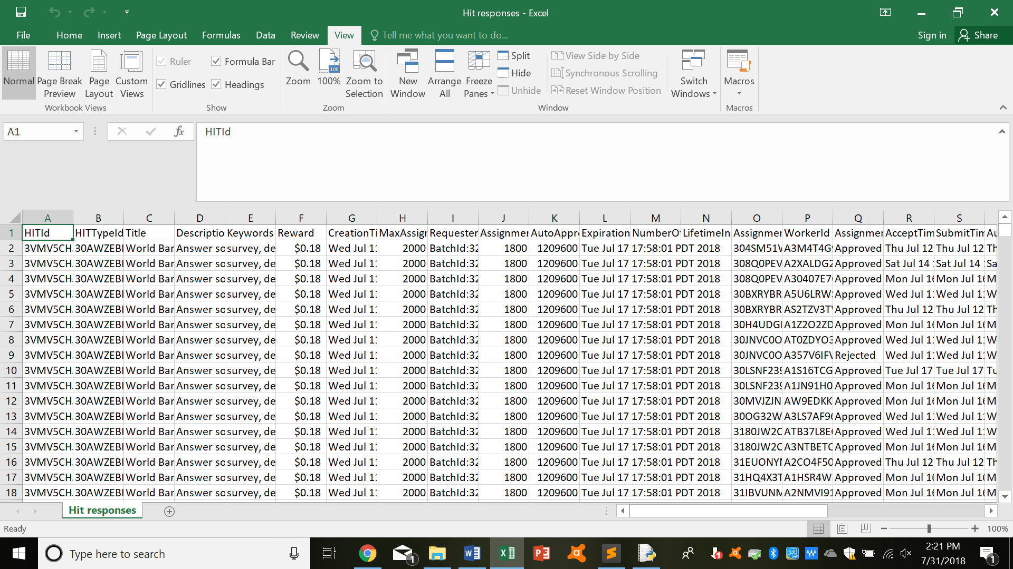

* Then go to “Hit Approver.py”, and modify the last line in the code accordingly (filling in the file name and the relevant CSV column names).

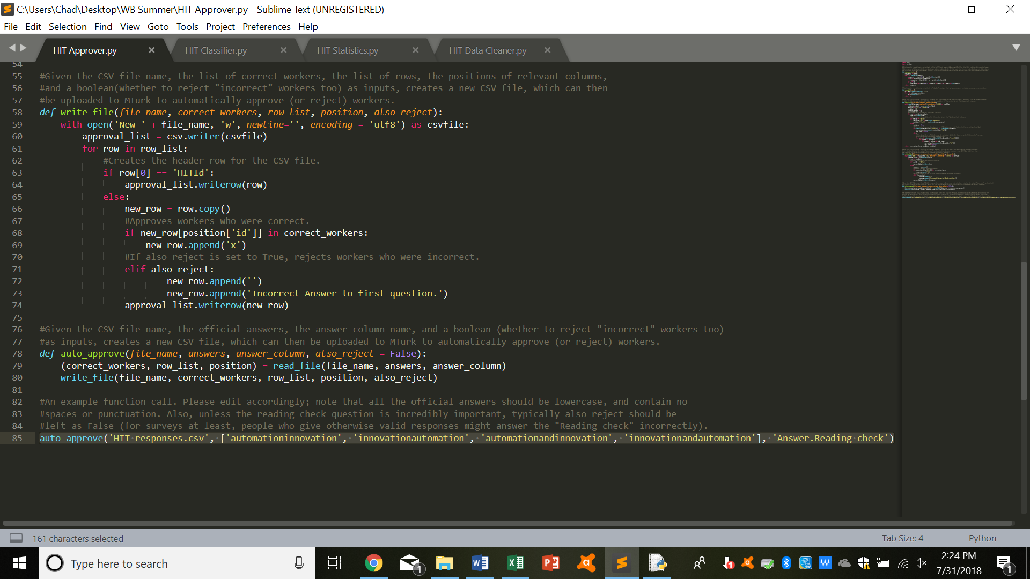

* Run “Hit Approve.py”, and you should see a new CSV file; the Approve (and Reject) columns should now be marked accordingly.

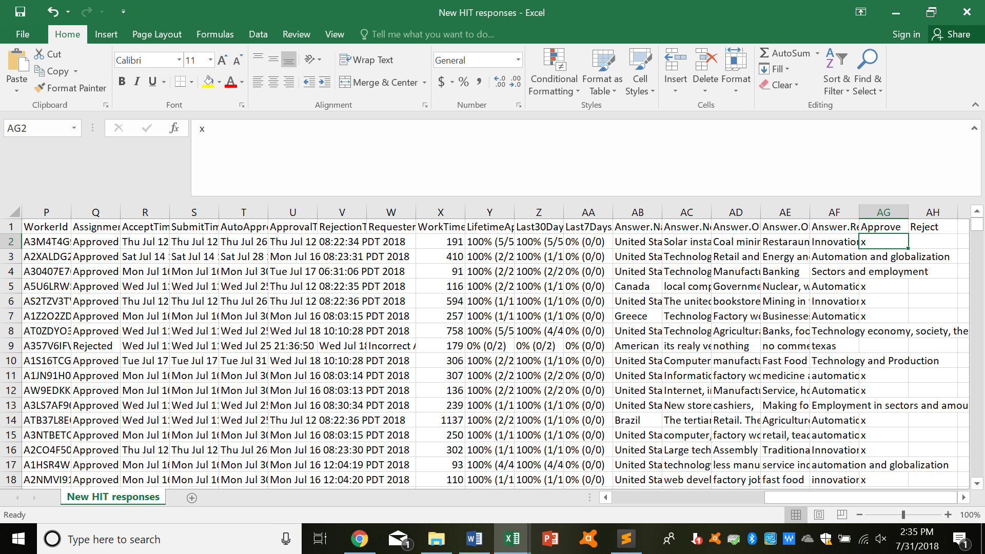

* Upload this onto Amazon Mechanical Turk, on the same page that you downloaded the original CSV file from, as described above. This will approve (or reject) the relevant workers.

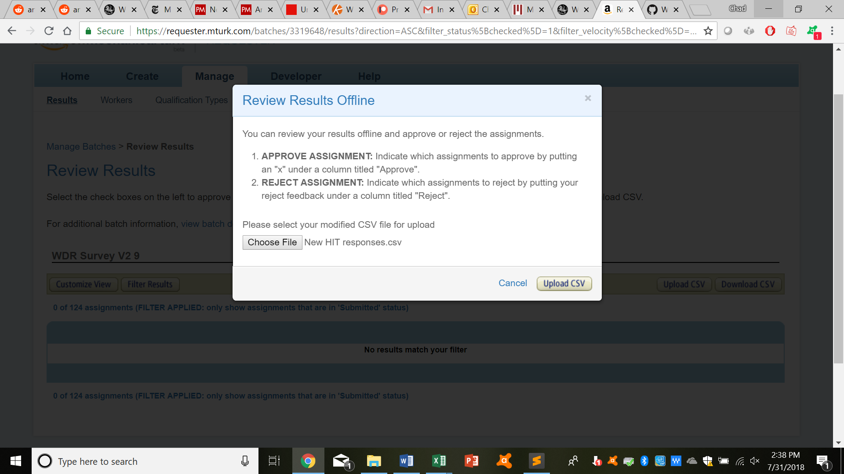

1. Assigning Qualifications:

* You can write a program that assigns a desired qualification to everyone who, say, has completed the current task successfully. For reference, check file “Hit Classifer.py”
* This is useful if you, say, want to relaunch a survey and want to stop people from taking it again.
* To start off with, start by downloading the relevant CSV files; the first is just the normal task CSV file, which can be found on the relevant HIT page.

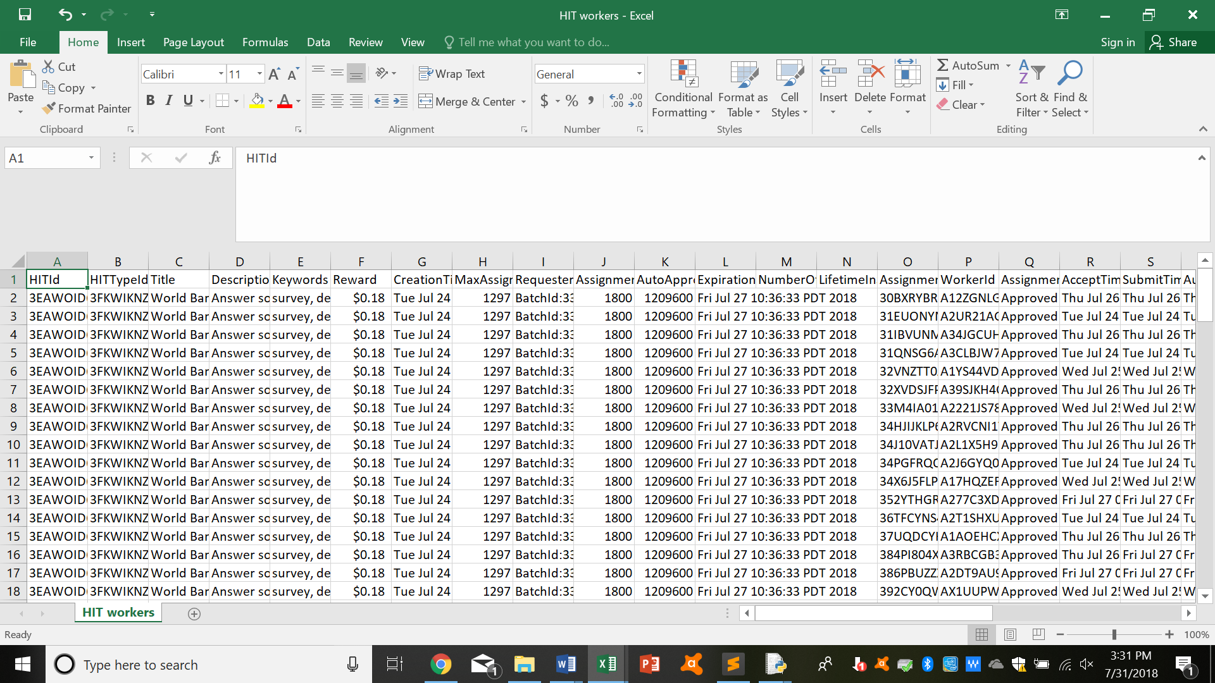

* The second is the CSV file containing all the workers who’ve worked for you before; this can be found on the Workers page, by clicking on the “Download CSV” button, as described above.

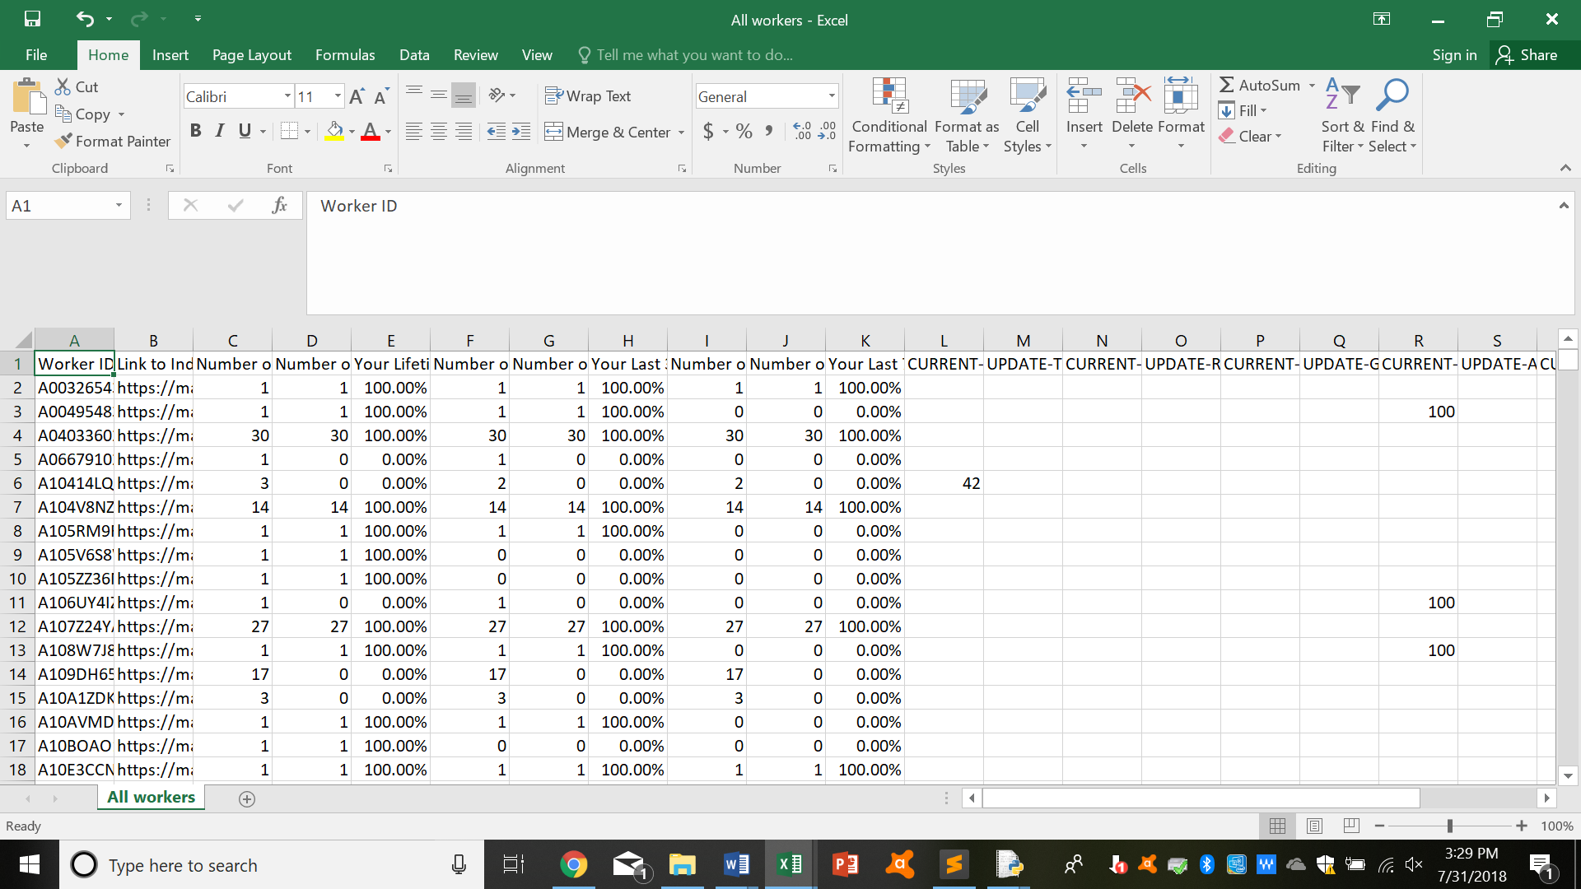

* Then go to “Hit Classifier.py”, and modify the last line in the code accordingly (filling in the file name and the relevant CSV column names).

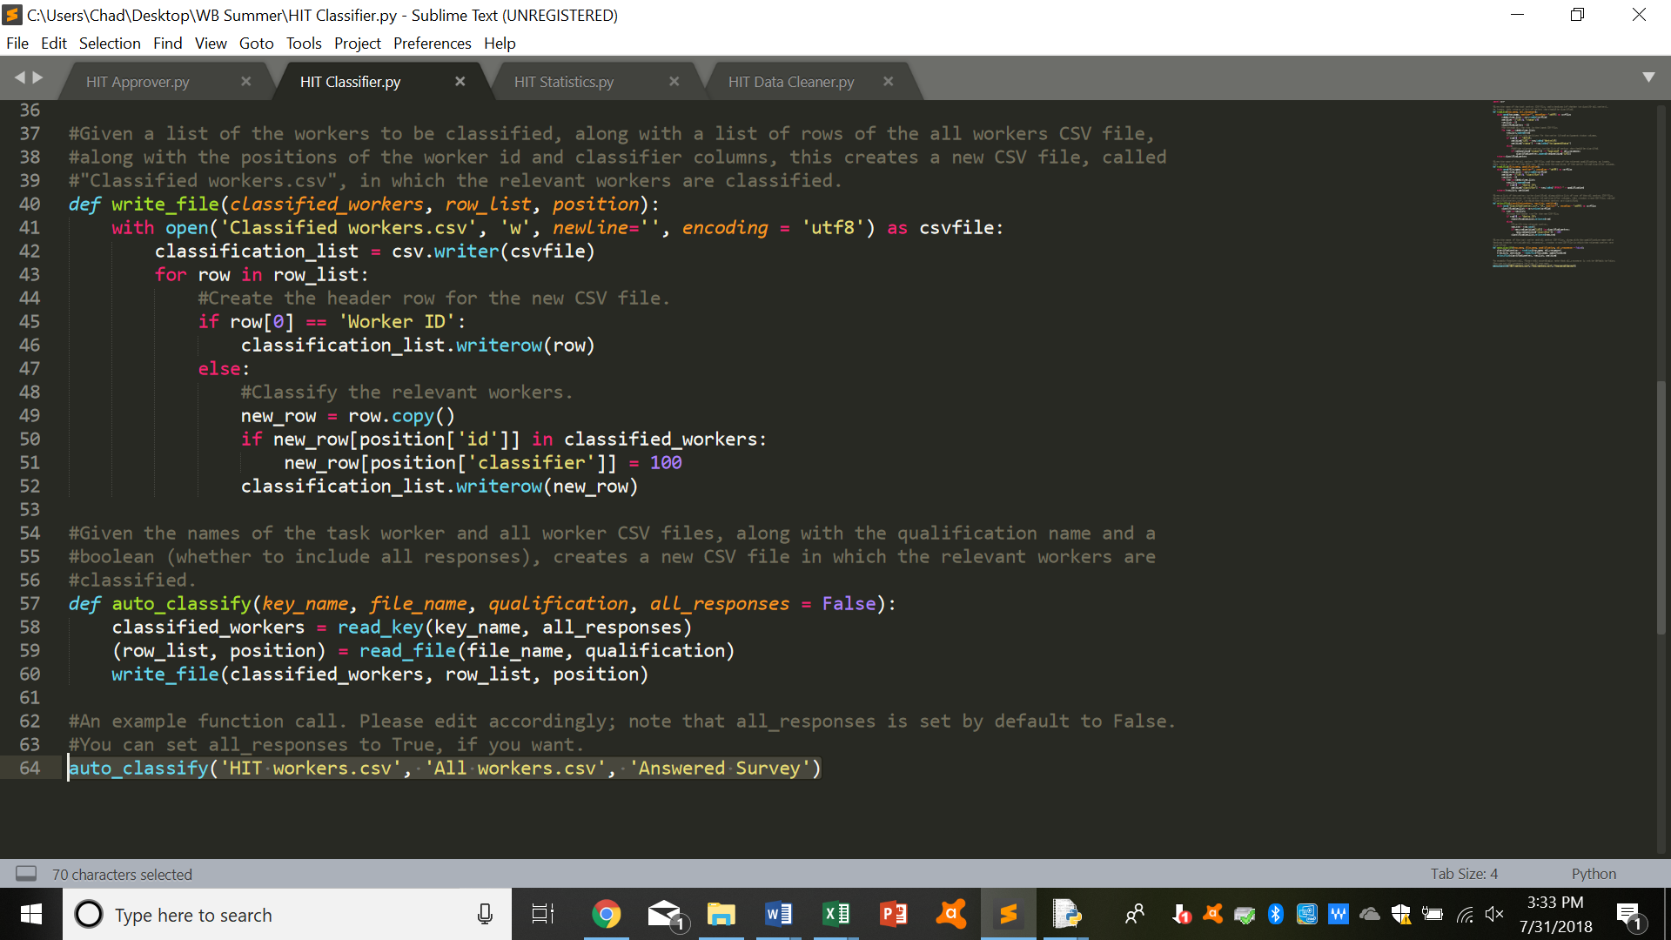

* Run “Hit Classifier.py”, and you should see a new CSV file; the appropriate classifier column should now be marked accordingly.

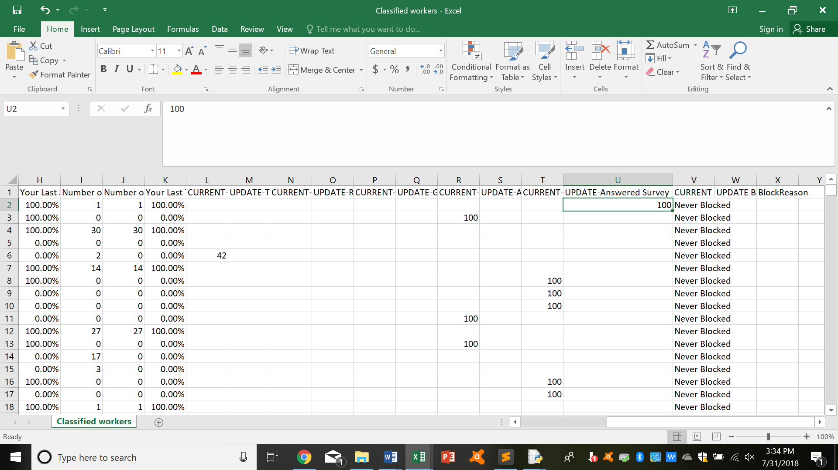

* Upload this onto Amazon Mechanical Turk, on the same page that you downloaded the original, all workers CSV file from, as described above. This will classify the relevant workers.

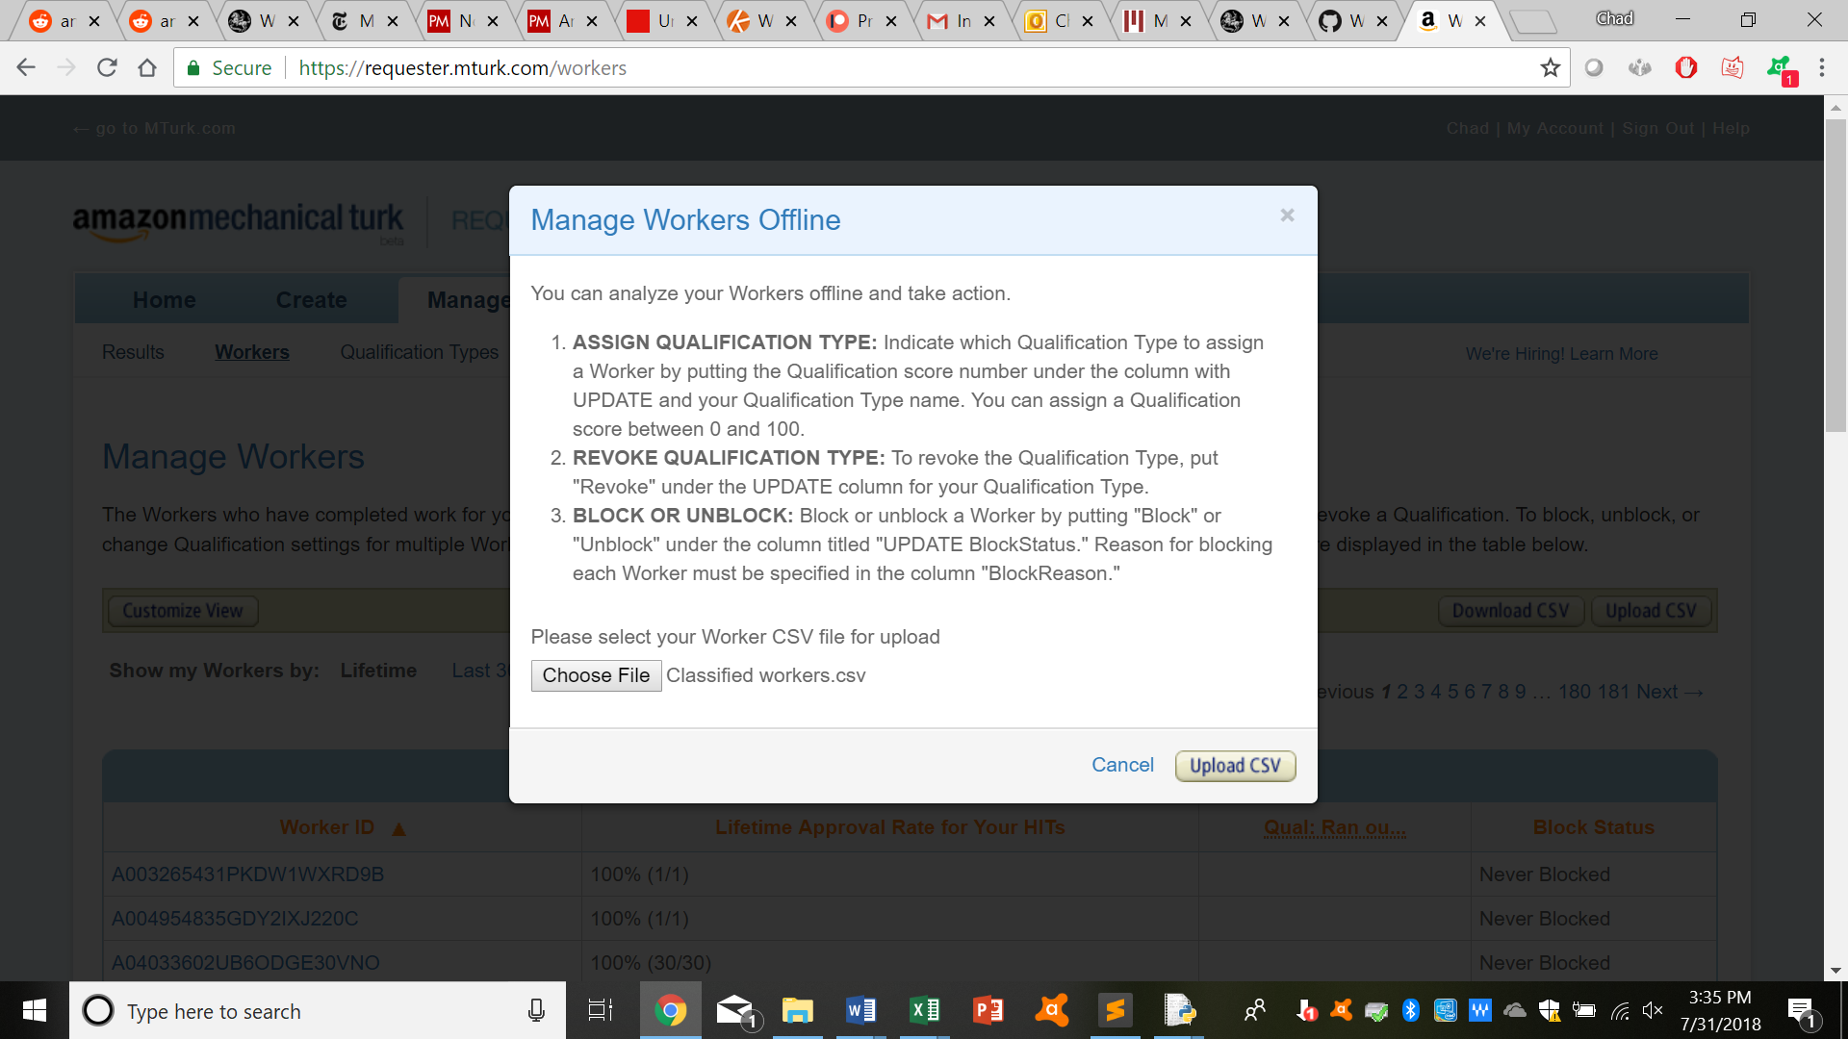

1. Gather simple “statistics”:

* You can write a program that goes through the responses you’ve received for free response questions (on your survey), and goes through and finds the most common words. For reference, check file “Hit Statistics.py”
* This is useful if you want to get a broad view of the kinds of responses that you’re receiving.
* To start off with, start by downloading the relevant CSV file, as described above.



* Then go to “Hit Statistics.py”, and modify the last line in the code accordingly (filling in the file name and the relevant CSV column names).

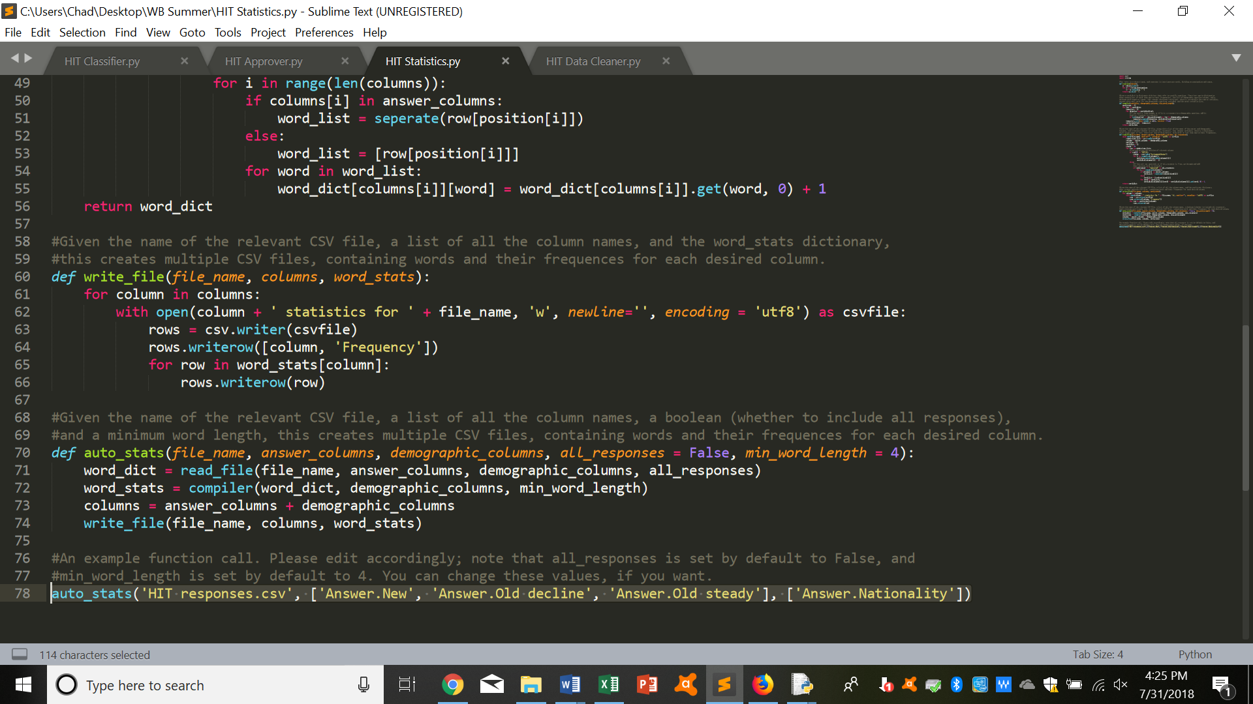

* Run “Hit Statistics.py”, and you should several new CSV files; check these out for the most common words.

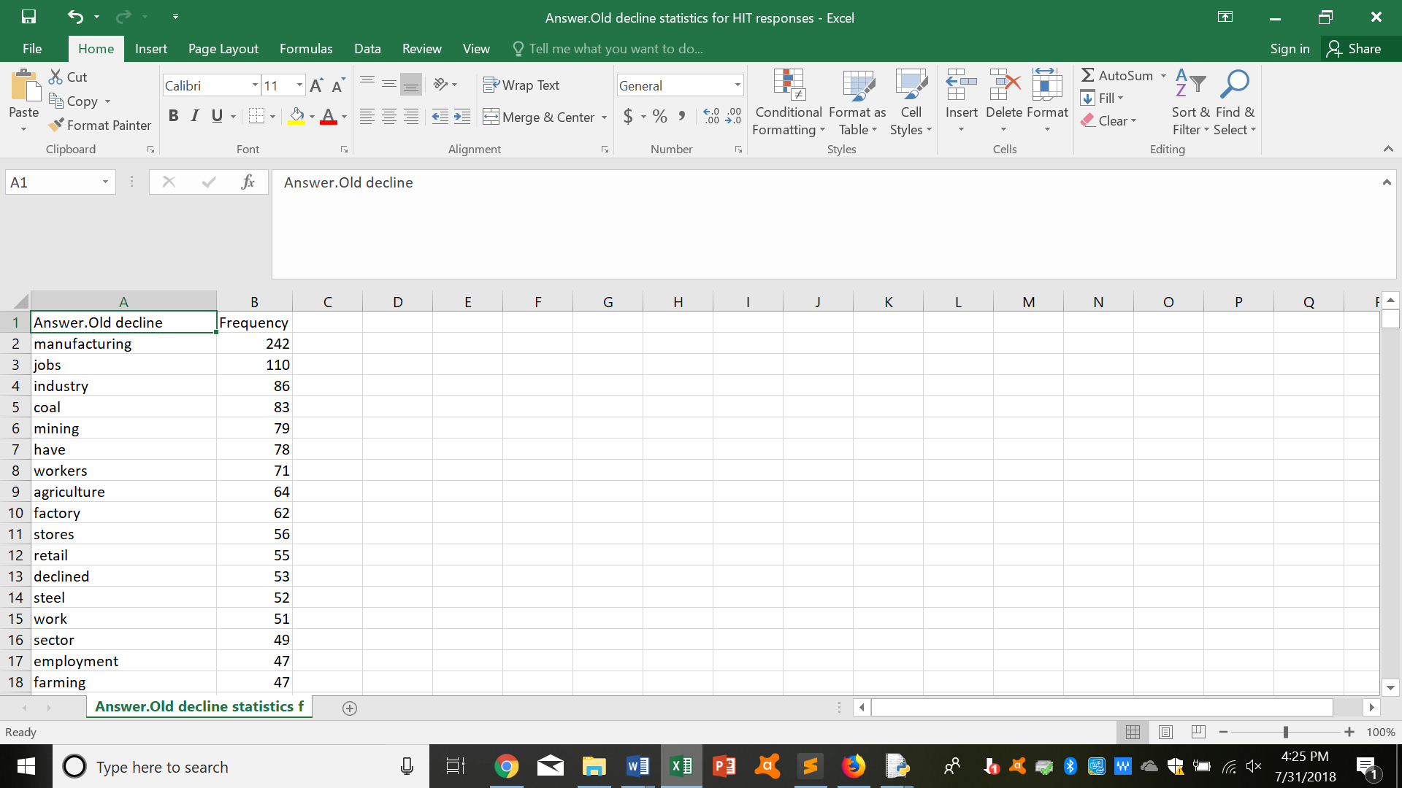

1. Finding the majority answer:

* You can write a program that goes through the responses you’ve received and returns the response that a majority replied (if this exists). For reference, check file “Hit Data Cleaner.py”
* This is useful if you’re having multiple people, say, tag images, and want to get the most “accurate” response.
* To start off with, start by downloading the relevant CSV file, as described above.

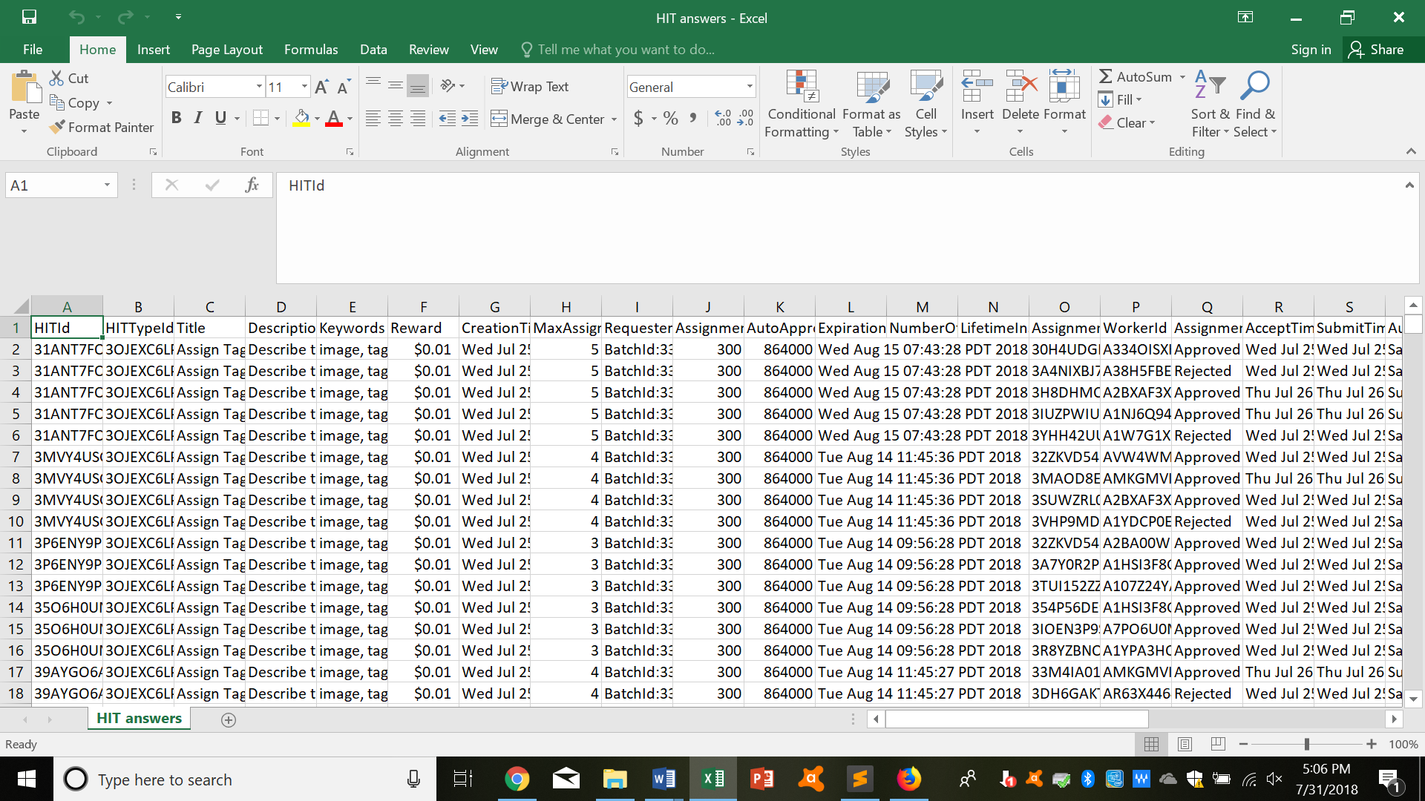

* Then go to “Hit Data Cleaner.py”, and modify the last line in the code accordingly (filling in the file name and the relevant CSV column names).

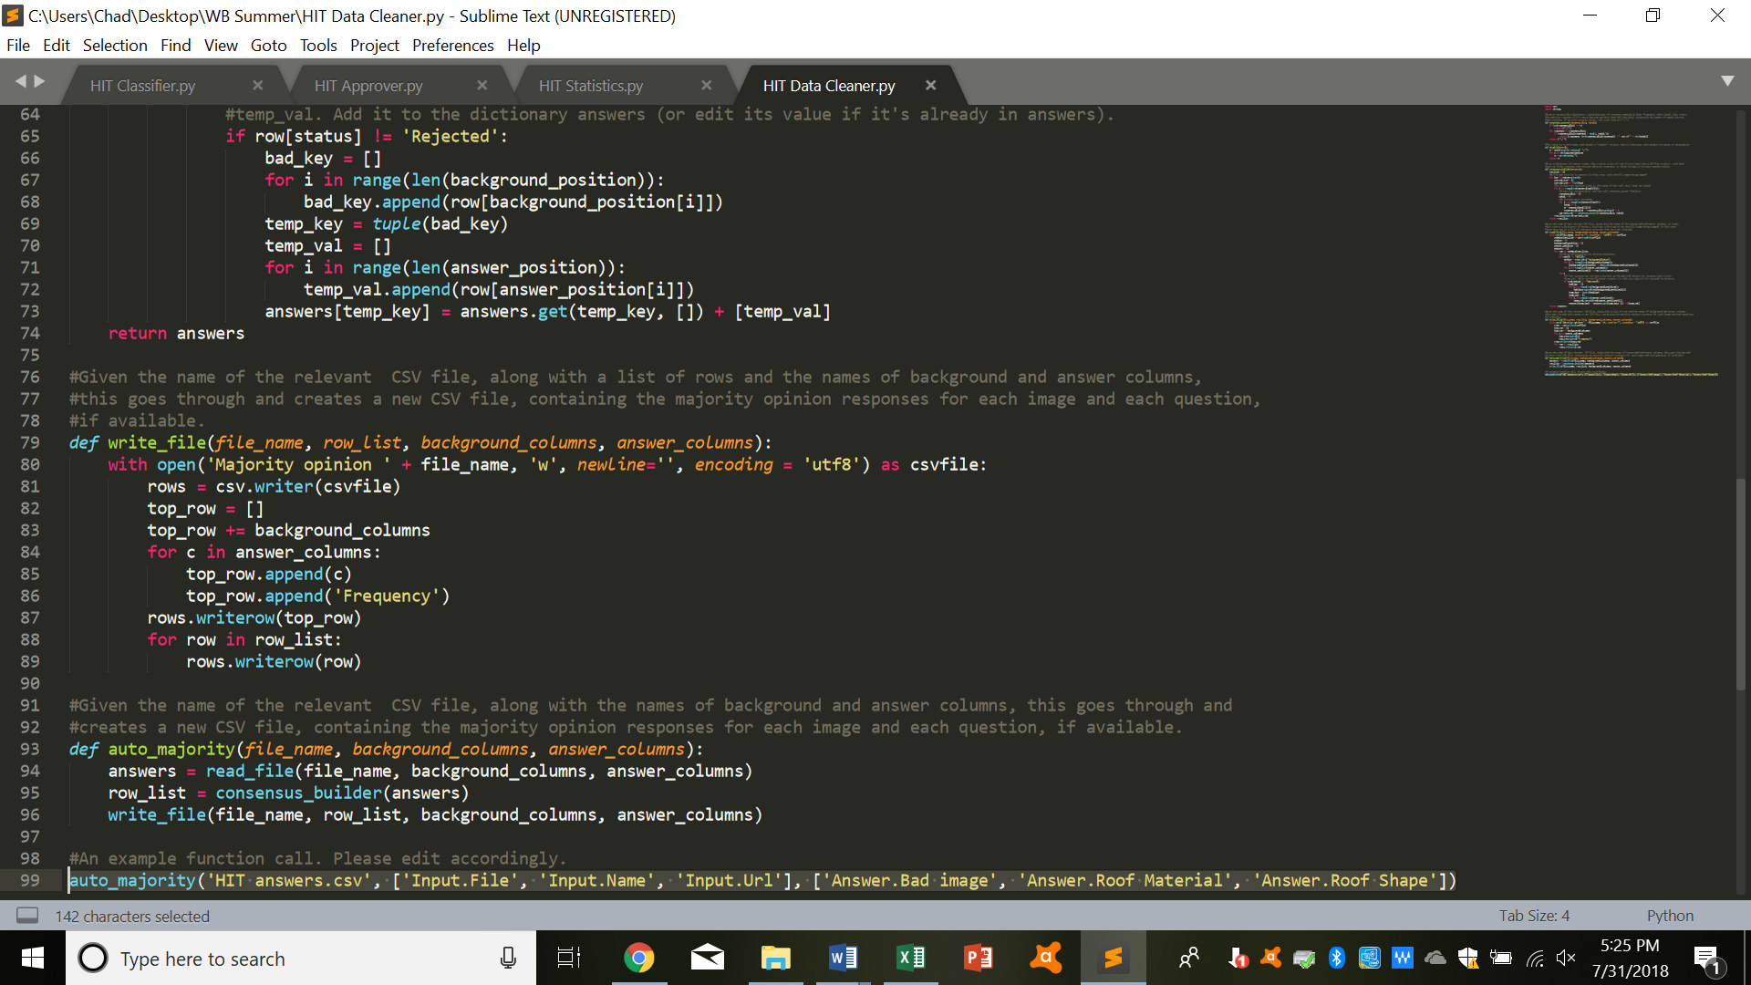

* Run “Hit Data Cleaner.py”, and you should a new CSV file; check this out for the majority opinion responses.

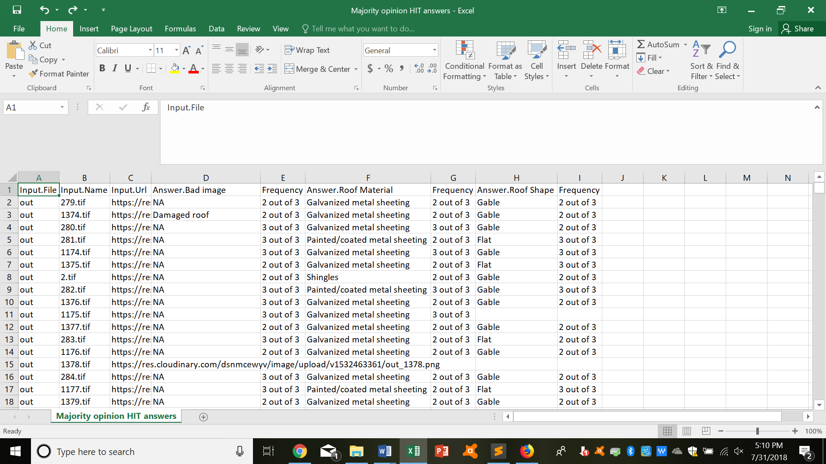

1. **Other tips/pointers:**
2. Amazon takes a 20% fee for tasks that hire up to 9 workers; it takes a 40% fee for tasks that employ 10 or more workers. Certain qualifications also cost money to use. More details on pricing can be found here: <https://www.mturk.com/pricing>.
3. Try to be generous with payment; you’ll also attract more workers if you offer higher pay.
4. Again, bonuses can be a good way to incentivize work that goes “above and beyond.” So consider using them!
5. Try to be prompt when approving work, so you have a good reputation on the platform.
6. Occasionally, Mechanical Turk workers will contact you about some issue; again, try to be prompt and nice when responding.
7. For data cleaning, you could have multiple workers do a single task, and then cross-verify. Take the majority opinion as the answer, and then approve or reject work accordingly.
8. For survey work, if you want demographic information, you have to include those questions in the survey itself; Amazon Mechanical Turk doesn’t provide that information for us (free of charge, at least).
9. If you want to limit tasks to a certain pool of workers, you can first create a qualification type, and then create a preliminary task, assigning the qualification type to those who pass the preliminary task. Then, you can create your main task, limiting it to people who have this qualification type. In general, this is better etiquette than just publishing a task that anyone can do, and then rejecting (and not paying for) a majority of the work because it doesn’t meet your standards.
10. Workers’ approval rate matters significantly for them; if it falls too low, they might not be able to find any good work. So please be generous when approving work.
11. You can cancel your task at any time; you will any pay for the work that you approve (including fees).
12. If your response rate is falling, you could try to cancel and resubmit your task, so that it appears higher up on the list of tasks (when sorted in chronological order), and becomes more visible for workers.
13. Again, you can email [mturk-requester-support@amazon.com](mailto:mturk-requester-support@amazon.com) for help, if you’re having difficulties on the platform.
14. You can also read Amazon’s guide for further help: <https://docs.aws.amazon.com/AWSMechTurk/latest/RequesterUI/Welcome.html>